MX7000/MX8000/MX9000 UV/Visible Spectrophotometer
Instruction Manual

Version : 2.0.0

Contents
Safety Information 1
Symbols and Conventions The following chart is an illustrated glossary of the symbols that are used in this manual. 3
Specifications 3
Overview 4
Basic Operation 6
Calibration and System Settings 10
Measurement 14
Photometry 14
Multi-wavelength 15
Kinetics 17
Time scanning 19
Quantitation 21
Biological Method 27
Spectrum Scanning 29
File management 31
User Management and Audit Trail 32
Performance Verification 38
Daily Maintenance 42
Troubleshooting 43
Spare Parts Replacement 44
Warranty 44
Compliance with local laws and regulations 45

Safety Information
Please read this manual thoroughly before operating the unit.
Follow all safety and operating guidelines to ensure proper use of the instrument.
Do not open the device.
Always disconnect the device from the main power supply before performing any maintenance or replacing fuses.
Danger: High voltage inside the device. Risk of electric shock.
Do not use the device if it is damaged, especially if the main power cable is frayed, cut, or defective.
Repairs must only be performed by authorized service technicians from your local MPD Scientific office or approved service partners.
Ensure the device is connected to a properly grounded power outlet.
Using the equipment in a manner not specified by the manufacturer may impair the protective features of the instrument.
Prevent liquids from entering the device.
Do not operate the device in hazardous or potentially explosive environments.

Package Contents
Description | Quantity
Spectrophotometer | 1PC
Glass Cuvette | 4PCS
Quartz Cuvette | 2PCS
Power Cord | 1PC
Instruction Manual | 1PC
Dust Cover | 1PC
Unpacking
After opening the package, carefully check the contents against the packing list. If any items are missing or damaged, please contact your local MPD Scientific office or an authorized service partner immediately.

Installation
Placement
Place the instrument carefully on a stable, level surface to ensure proper operation and to prevent vibration or accidental movement.
Connecting the Power Cord
Before connecting, make sure the instrument’s power switch is turned off.
Insert the female end of the power cord into the instrument’s power inlet, then plug the male end into a properly grounded power outlet.

1 – Power inlet | 2 – Power cord
3 – Power outlet

Connecting to a Computer
Plug one end of the USB cable into the instrument’s USB Type-B (square) port, and the other end into the computer’s USB Type-A (flat) port.
Note: The USB cable is an accessory for the PC application. It is optional and must be purchased separately, as it is not included with the standard instrument configuration.

1 – USB port of computer（Type A, flat） | 2 – USB port of instrument（Type B, square）
  - Connecting Other Peripherals
1 – HDMI（Connect HD external display） | 2 – VGA（Connect external display）
3 – Ethernet (connected to the network) | 4 – USB（Connect USB flash drive, keyboard, mouse, WIFI, Printer，etc.）
5 – Temperature controller port

Symbols and Conventions
The following chart is an illustrated glossary of the symbols that are used in this manual.
 | CAUTION Indicates a potential risk and alerts the user to proceed with caution.
 | HIGH VOLTAGE Warns of the presence of high voltage. Follow all safety procedures to avoid electric shock.
 | HOT SURFACE Indicates a risk of burns due to hot surfaces. Avoid contact during or after operation.

Specifications

Model | M7000 | M8000 | M900
Optical System | Double Beam
Light Source | Flash Xenon Lamp
Wavelength Range | 190-1100nm
Band Width | 1.8nm | 1nm | 0.5/1/2/4/5nm
Stray Light | ≤0.05%T @ 220nm & 340nm
Photometric Range | 0 to 400%T, -4 to 4A, 0 to 9999C
Wavelength Accuracy | ±0.3nm
Photometric Accuracy | ±0.3%T or ±0.004A @ 1A
Stability | 0.0005A/h @ 500nm
Baseline Flatness | ±0.002A(200~1000nm)
Language | English, Chinese
Display | TFT Color LCD (10.1”, Touch Screen)
Storage | 64GB
Interface | USB-A, USB-B, HDMI, VGA, Ethernet
Measuring Procedure | Photometry, Multi Wavelength, Kinetics, Time Scanning, Quantitation, Spectrum Scanning, DNA/Protein
Power Supply | 100~240V AC，50~60Hz，100W
Dimension | 580×420×235mm
Weight | 17kg |  | 18kg
Work Environment | 15 to 35℃, 15 to 70% relative humidity
Store Environment | -10 to 50℃, 15 to 70% relative humidity

Overview
The MX7000, MX8000, and MX9000 UV/Visible Spectrophotometers are versatile instruments designed for precise and reliable analytical measurements. They are widely used across various industries, including chemistry, pharmaceuticals, biotechnology, metallurgy, materials science, environmental testing, light industry, textiles, medical research, and education.
These spectrophotometers are ideal for routine analysis, quality control, and research applications, providing accurate results and dependable performance in laboratory environments.
Turn the instrument power on/off
- Turn on the main power switch located on the back of the instrument.
- Press the blue Start/Stop button on the front panel to power on the instrument.
Note:
Avoid turning the instrument on and off repeatedly in quick succession. Wait at least 30 seconds before restarting. Rapid cycling of power may cause damage to the electrical and mechanical systems.
Self-check and calibration
- Ensure that the sample chamber is empty and that no objects are obstructing the light path.
- On the computer, double-click the UV Studio icon  on the Windows desktop to launch the software.
- The instrument will automatically perform a self-check and calibration sequence, which includes the following steps:
  - Activating the lamp and positioning the light source switching mechanism
  - Positioning the filter disc
  - Positioning the slit switching mechanism (if installed)
  - Positioning the automatic sample holder (if installed)
  - Measuring dark current
  - Positioning the wavelength
  - Checking energy levels
  - Verifying the system baseline
After the self-check is complete, the instrument is ready for operation.
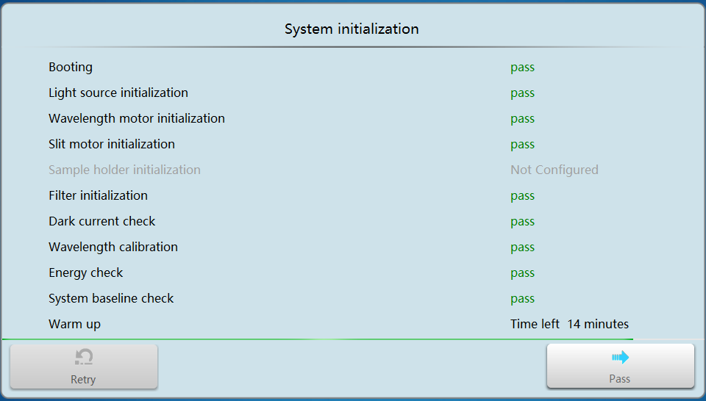
User login
If the User Management and Audit Trail module is enabled, the User Login interface will appear after the self-test is completed.
- On the login screen, select your username from the list.
- Enter your password using the on-screen or connected keyboard.
- Press “Login” to access the system.
Only authorized users can operate the instrument when this module is active.
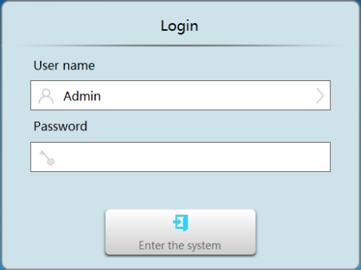
General Operating Instructions
Touch Screen Operation
- You can interact with the screen using your fingertip, nail, or stylus.
- Do not use sharp objects, such as ballpoint pens or metal tips, as these may damage the screen surface.
- Avoid excessive pressure.
Using the keyboard
The instrument provides two types of keyboards to suit different input needs:
- Numeric Keypad: Used for entering numerical parameters or measurement values.
- Full Keyboard: Used for entering text-based information such as usernames, passwords, and file names.
When entering text, ensure accuracy, as file and usernames are case-sensitive within the system.
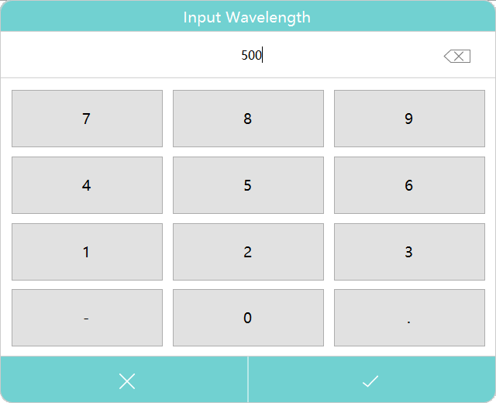
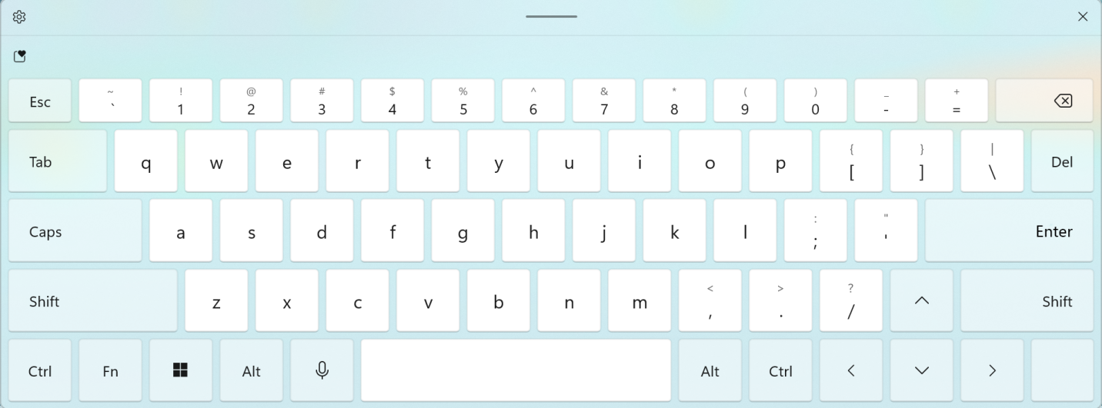

Basic Operation
Enter an application module using the main interface.
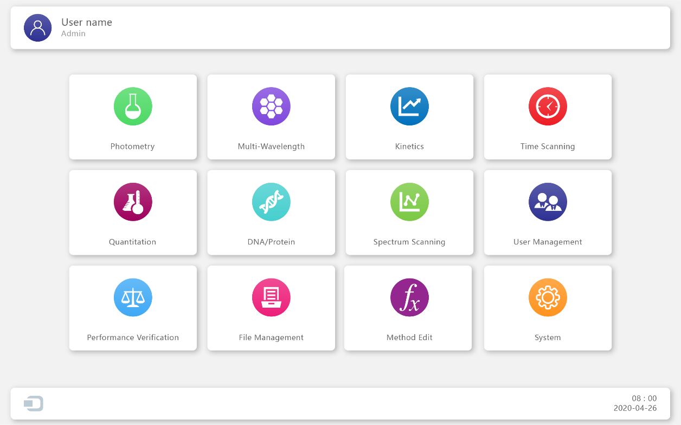
 | Photometry  Measuring the photometric value of a sample at a single wavelength.
 | Multi wavelength  Measuring the photometric value of a sample at multiple wavelengths.
 | Kinetics  Measuring the change in absorbance or absorbance change rate over time at a specified wavelength.
 | Time scanning  Measuring the change of photometric value with time at a single wavelength.
 | Quantitation  Establish a standard curve and measure the concentration of the sample using a standard curve.
 | Biological method measurement  Measuring DNA, RNA and protein concentrations using built-in methods or new methods.
 | Spectrum scanning  Measuring the photometric curve of a sample over a range of spectra.
 | User management  Assign user rights, operate log management.
 | Performance verification  Verify the technical performance of the instrument.
 | File management  Efficient management of user files, browsing, copying, renaming, and deleting operations.
 | Custom method  Users can add calculation methods for special applications or exploratory studies according to their needs.
 | System  Set system parameters and system calibration.

Back to main interface
Press the home icon  to return to the main interface.
Return to previous interface
Press the back arrow icon  to go back to the previous interface.
Do blank/Scan baseline
In the Measurement Interface, place the reference cuvette (usually containing the blank solution) in the reference channel and in the measurement channel, press to perform a baseline scan.
Measuring sample
In the Measurement Interface, place the reference cuvette in the reference channel and the sample cuvette on the measurement channel. Press to perform the measurement.
Enter data/curve list
In the measurement interface, press  to enter the data/curve list.
Measurement Results Operation
 | Open  Open a stored file, load data or parameters.
 | Save  Save data, parameters to storage.
 | Print  Print test report.
 | Export to MS Word  Export file to MS Word format.
 | Export to MS Word file format  Export file to MS Excel format.
 | Export to MS Word file format  Export file to PDF format.
Delete
Delete the selected results.

Calibration and System Settings

To display calibration options and configure basic instrument settings, select the  icon within the main interface.
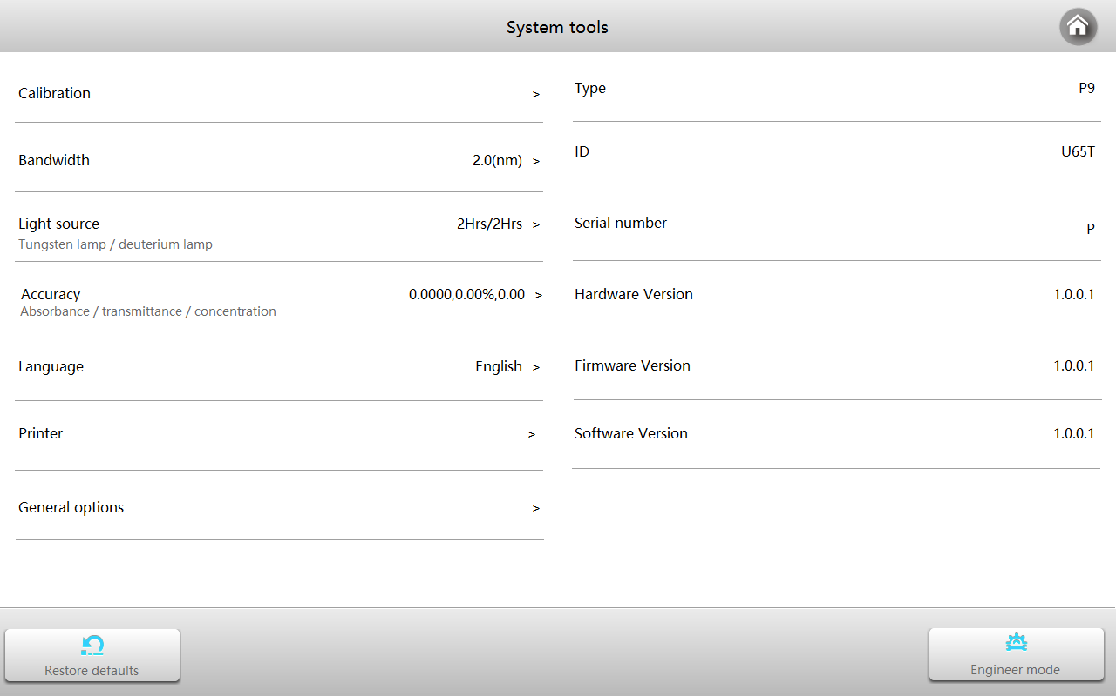
System Calibration
- From the System interface, select the Calibration tab.
- Ensure that all samples are removed from the measurement channel.
- Close the sample chamber cover securely.
- Select one of the following calibration options to perform the desired calibration procedure:
  - Wavelength Calibration
  - System Baseline Calibration
  - Dark Current Calibration
The instrument will automatically execute the selected calibration process.
Important:
Before performing any calibration, make sure the measurement channel is empty and the sample chamber cover remains closed for the entire duration of the calibration.
Failure to follow these steps may affect calibration accuracy and instrument performance.
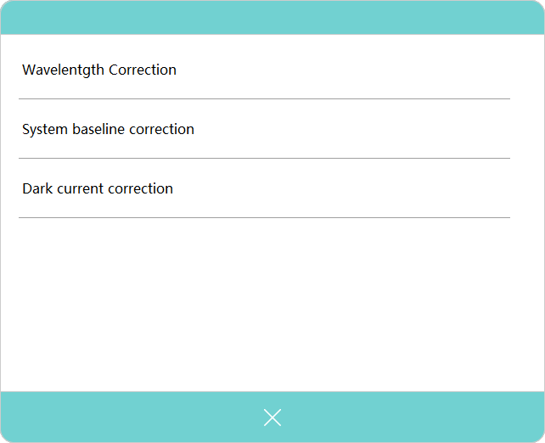
Bandwidth setting
- From the System interface, select the Bandwidth tab.
- Choose the desired spectral bandwidth from the available options.
- The instrument will automatically adjust to the selected bandwidth setting.
Important:
After changing the spectral bandwidth, the instrument must be recalibrated.
Before adjusting the bandwidth:
- Remove any samples from the measurement channel.
- Close the sample chamber cover and keep it closed throughout the process.
The full procedure for switching bandwidth and completing recalibration typically requires 3–4 minutes.
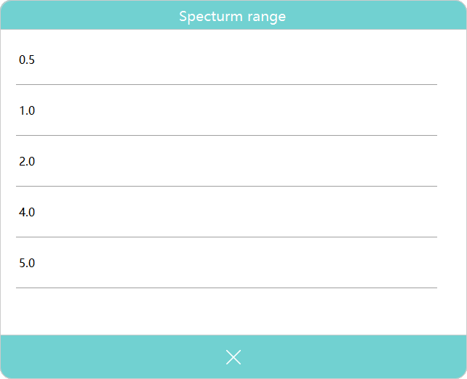
Result resolution setting
Press the tab Result Resolution. Select the resolution of the required display digits according to different measurement modes.
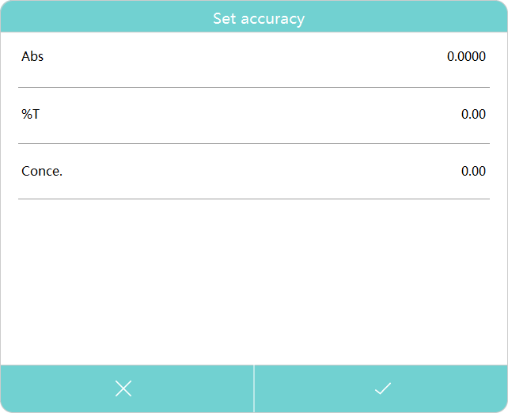
Light source management
Press the tab Light source, which displays the usage timing of the light source and the switching wavelength of the light source.

Language setting
Press the Language tab to select the desired language.
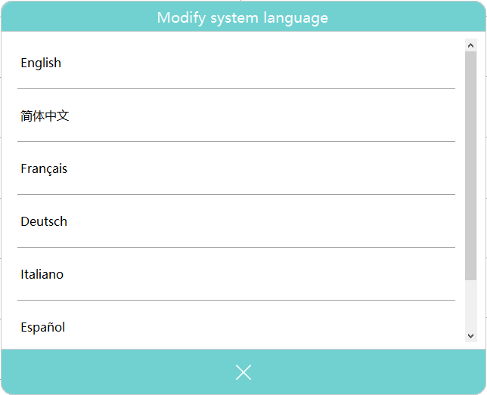
Printer setting
Press the Printer tab to select the installed printer.
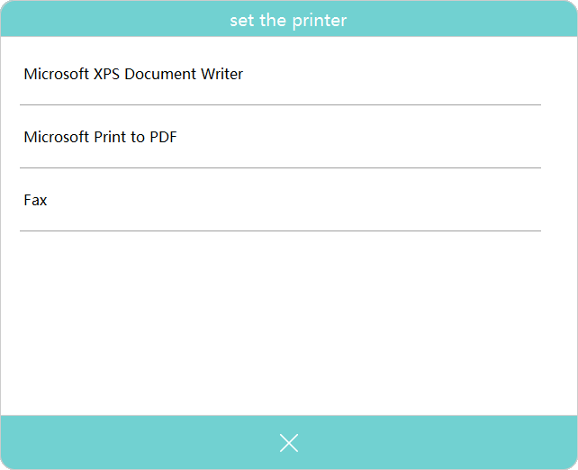
Lamp Control

Turn On/Off Lamp
Press the 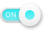 icon to switch the Tungsten lamp or Deuterium lamp on or off.

Note: When using only one light source for an extended period, turn off the unused lamp to conserve energy and extend lamp life.

Set Light Source Switching Wavelength

Press the current switching wavelength value to open the numeric keypad. Enter the desired wavelength, then press  to confirm.

Note: After changing the light source switching wavelength, perform a system baseline calibration to ensure accurate measurement results.

Reset Lamp Timing

Press the icon to reset the Tungsten lamp or Deuterium lamp operating time.

Note: To maintain accurate lamp timing, perform the timing reset only after replacing the lamp. Do not reset at other times.

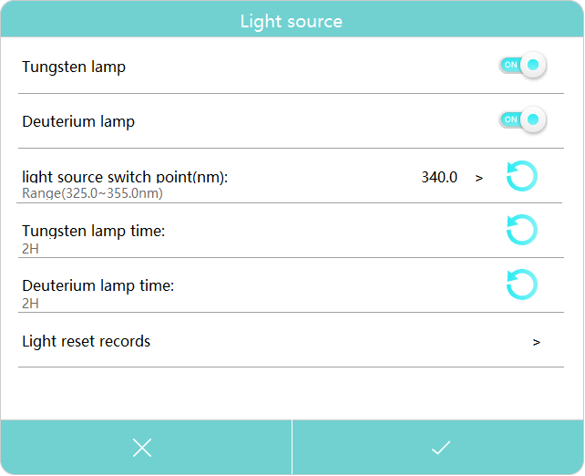

General settings
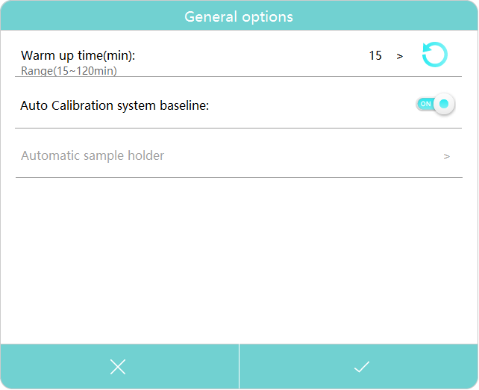
Setting the Lamp Warm-Up Time
- Press the “Warm Up” button in the system interface.
- A numeric keyboard will appear on the screen.
- Enter the desired warm-up duration (1–120 minutes).
- Press the [Confirm] button to save the setting.

The instrument will now warm up for the specified time before becoming ready for measurement.

Calibrate System Baseline at Startup
- To enable or disable automatic baseline calibration at startup, press the icon.
- When the option is enabled, the instrument will automatically perform a baseline calibration each time it is powered on.
- When disabled, calibration must be performed manually after startup as needed.

Measurement

Important Guidelines
Warning:
Always follow proper laboratory safety procedures when handling reagents and samples. Failure to do so may result in injury or contamination.
- Reagents and buffers may be corrosive and can cause skin burns or other health hazards.
- Samples (such as nucleic acids, proteins, or bacterial cultures) may be infectious and pose serious health risks.
- During sample preparation, measurement, maintenance, and cleaning, follow all local laboratory safety regulations.
  - Always wear appropriate personal protective equipment (PPE), including lab coats, gloves, and safety goggles.
  - Use disinfectants and containment procedures as required.
- Dispose of all measurement solutions, cleaning agents, and disinfectants according to local laboratory waste disposal regulations.
Check the cuvettes
Before measurement:
- Ensure all cuvettes are clean, clear, and free of sample residue on the optical surfaces.
- Only quartz cuvettes should be used for measurements in the ultraviolet (UV) range, as other materials may absorb UV light and affect accuracy.

Photometry
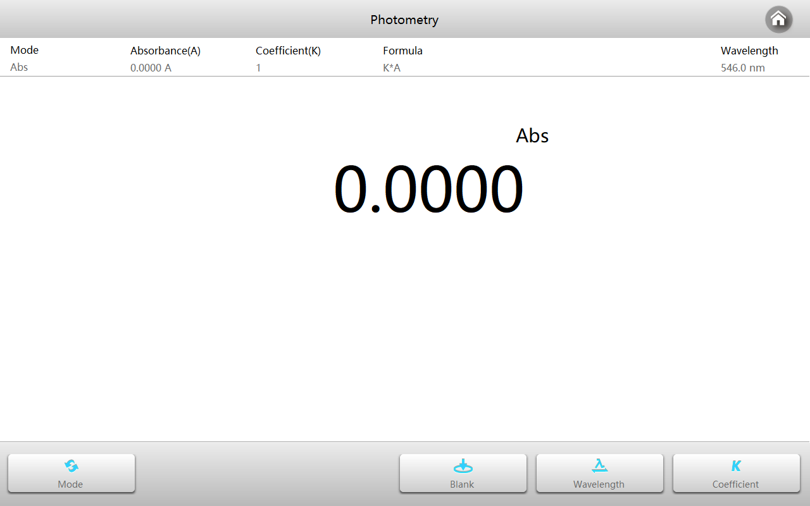
Photometry Mode is used to measure the Absorbance (Abs), Transmittance (%T), or Reflectance (R%) of a sample at a single wavelength.
This mode is ideal for quick and precise quantitative analysis of known samples.

Within the Main interface, press the icon  to start a Photometry application.

Press the icon to switch to the measurement mode.
Abs | Measure absorbance value of the sample(s).
%T | Measure transmittance value of the sample(s).
%R | Measure reflectance value of the sample(s).
Press the button to set wavelength, key in the desired measurement wavelength.
In the Photometry Mode, choose Abs (Absorbance) as the measurement type.

- To apply a coefficient, press the button and set the coefficient (K value) as needed. The instrument will automatically calculate K × A during measurement.
Perform Blank Measurement
- Place the reference cuvette (blank solution) in both the reference channel and the measurement channel.
- Press the blank button to perform baseline correction.
- Wait for the system to confirm completion of the blank measurement.
Measure the Sample
- Replace the cuvette in the measurement channel with the sample cuvette.
- Leave the reference cuvette in the reference channel.
- Press the [Measure] button to record the absorbance reading.
- The measured value (Abs or K·A) will be displayed on the screen.

Multi-wavelength
Multi-wavelength mode is used to measure the absorbance or transmissivity of the sample at multiple wavelengths.
Within the Main interface, press the icon  to start a Multi-wavelength application.
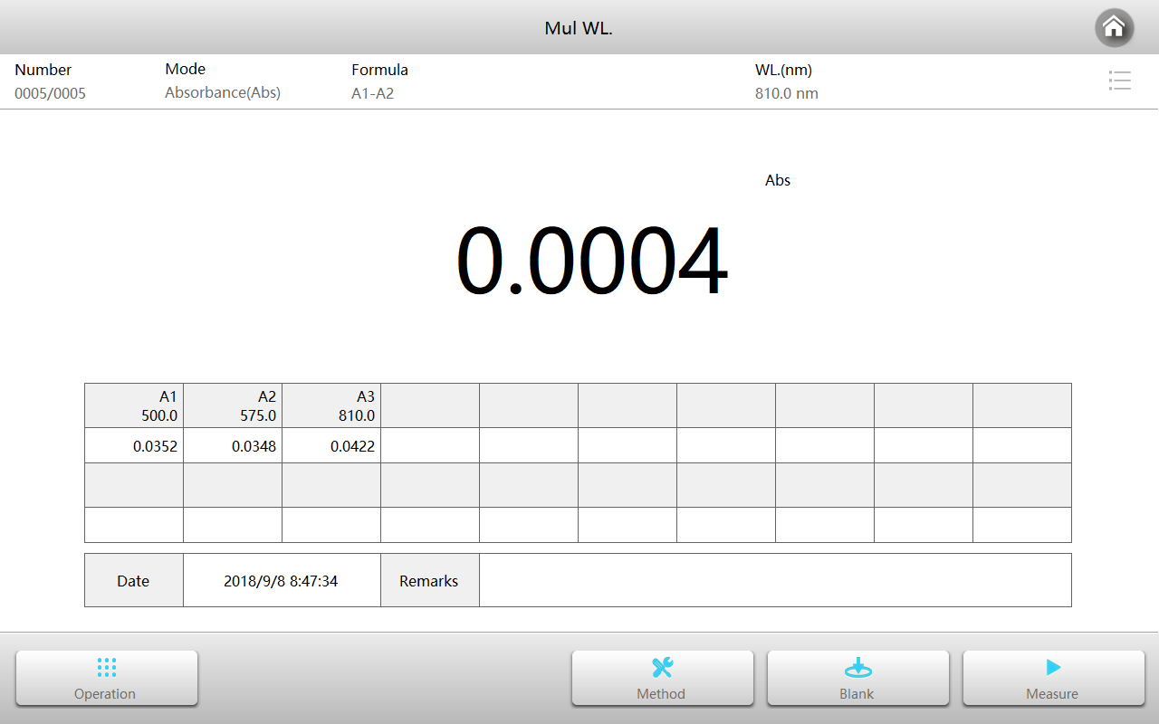
Press the button to set the measurement parameters. Press to accept the new parameters and return to the measurement interface.
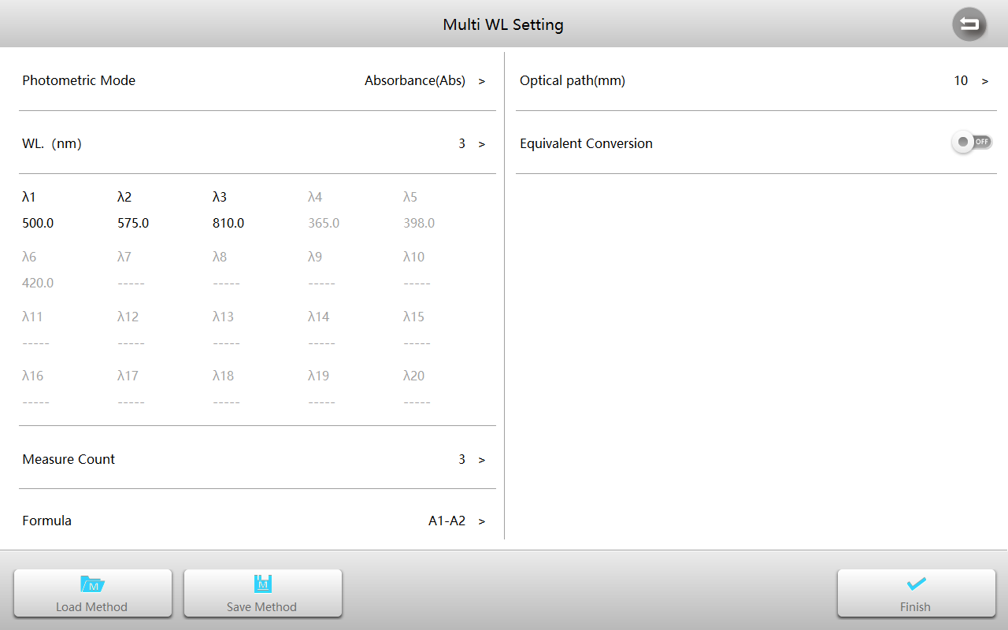
Photometric mode | 3 photometric modes: Abs, %T, %R.
Wavelength | 1~20 wavelengths are available, wavelength range: 190~1100nm.
Cycles | 1, 2, 3, 5, 10, 20, 30, 50 times can be selected, the instrument will calculate the average as the final output.
Calculation formula | The instrument can choose to embed the calculation formula to directly calculate the result. The formula can support user customization (in the custom method module).
Light path length | The width of the cuvette used for the measurement.
Equivalent conversion | Activation automatically converts measurements from different path cuvettes to values in the 10mm light path length.
Put the reference in the measurement channel and reference channel, close the sample chamber cover, and press the button to blank.
Put the sample in the measurement channel, close the sample chamber cover, and press the button to measure and calculate results.
Repeat to measure more samples.
Press  to switch to list mode to browse the list of measurement results.
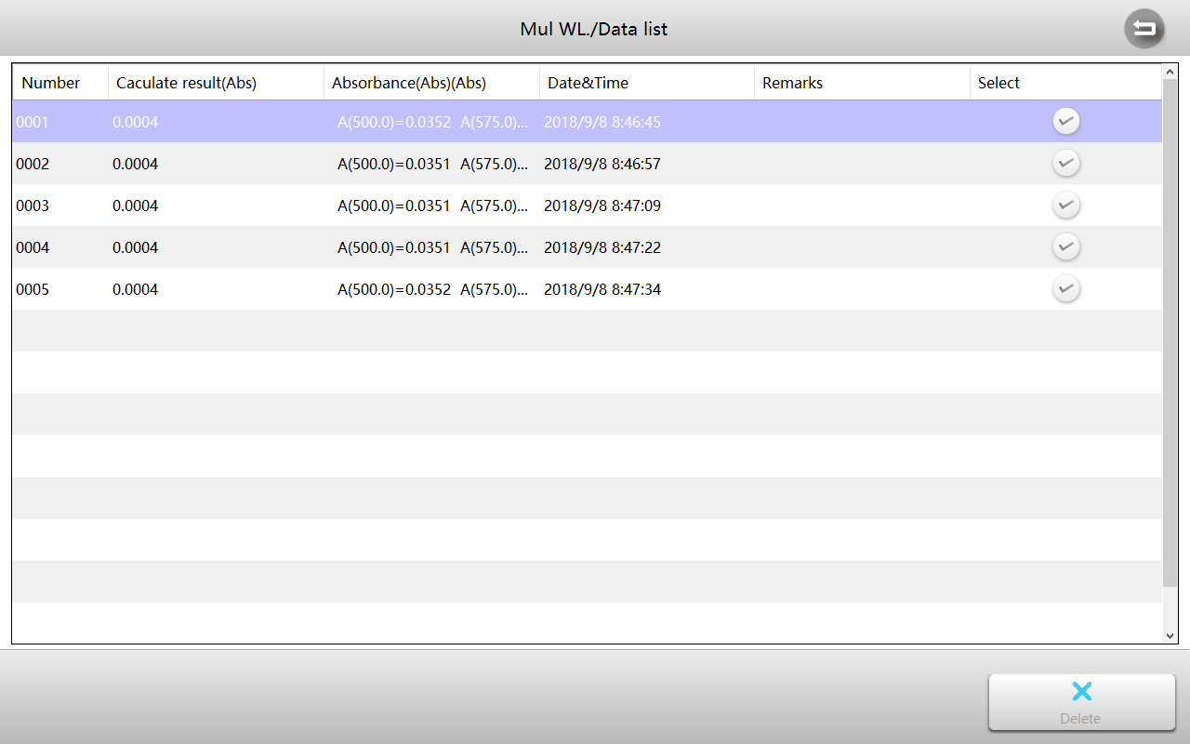

Kinetics
Kinetics mode is used to measure the rate of change of the sample.
Within the Main interface, press the icon  to start a Kinetics application.
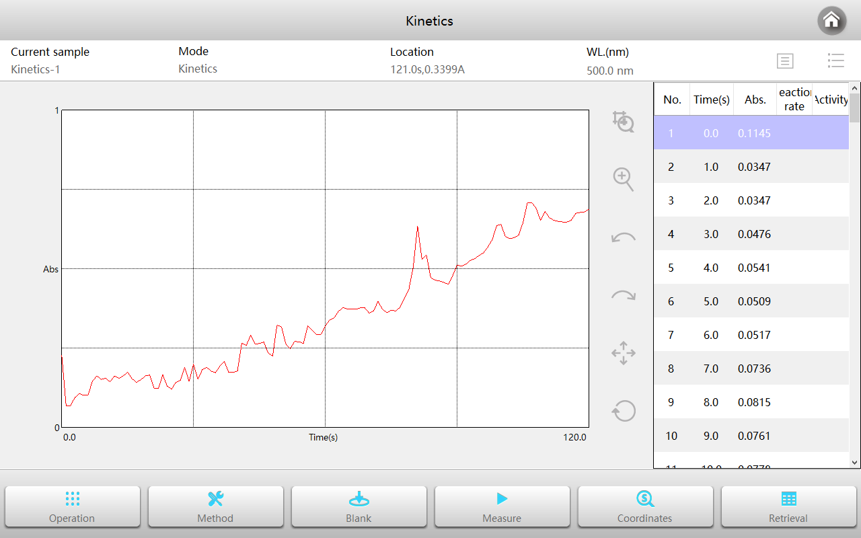
Press the button to set the measurement parameters. Press the button to accept the new parameters and return to the measurement interface.
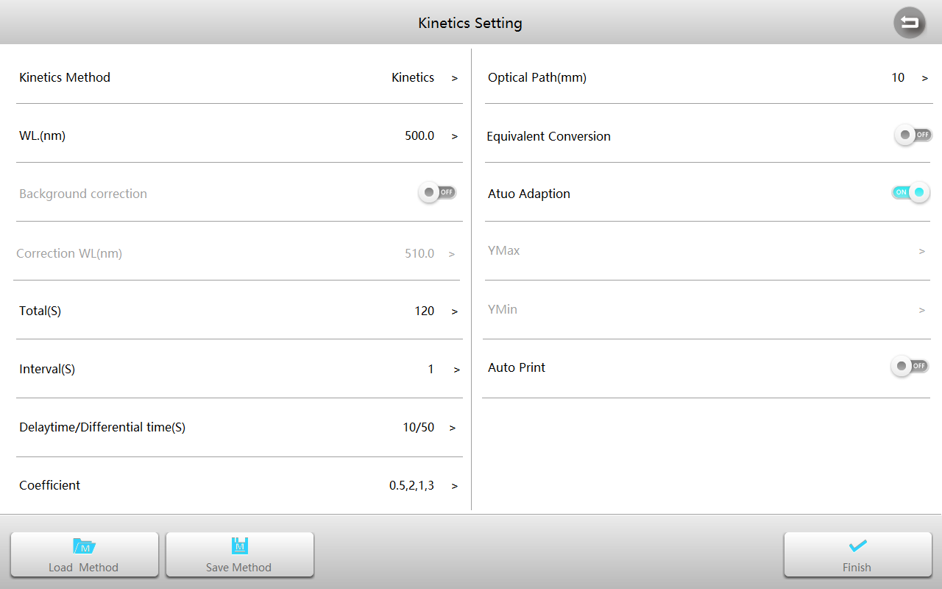
Measurement mode | 2 measurement modes: kinetics, kinetic rate.
Wavelength | Measured wavelength, range: 190~1100nm.
Background correction | Background correction switch, can be set according to actual needs.
Corrected wavelength | Background corrected wavelength, range: 190~1100nm.
Total | Measure the total sampling time required.
Interval | Sampling interval.
Delay/Derivative | Waiting time before starting sampling/time of participating activity calculation.
Coefficient | Coefficient of activity calculation equation.
Light path length | The width of the cuvette used for the measurement.
Equivalent conversion | Activation automatically converts measurements from different path cuvettes to values in the 10mm light path length.
Auto scale | Whether to automatically adjust the coordinates based on the data.
Y max | The maximum value of the ordinate (valid only when the coordinates are fixed).
Y min | Minimum value of the ordinate (valid only when the coordinates are fixed).
Automatic printing | Automatically print curves and results after measurement is complete.
Automatic save | Automatically save curves and results after measurement is complete.
Put the reference in the measurement channel and reference channel, close the sample chamber cover, and press the button to do blank.
Put the sample in the measurement channel, close the sample chamber cover, and press the button to measure and get sampled data and draw the curve.
Repeat this process to measure more samples.

Time scanning
Time scanning mode is used to measure photometric value changes of the sample.
Within the Main interface, press the icon  to start a Time scanning application.
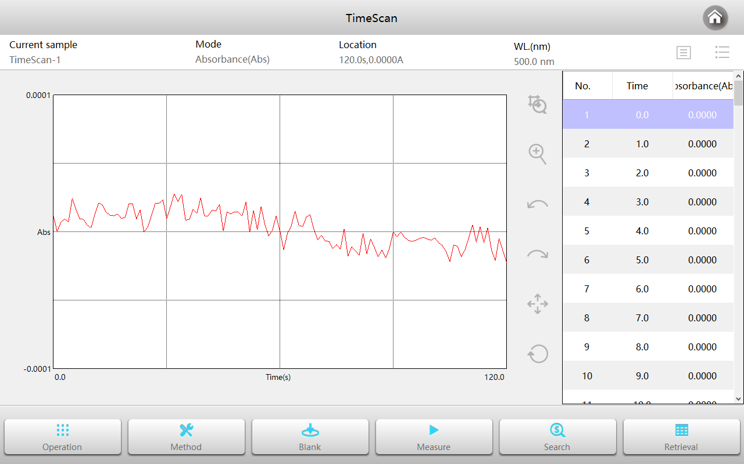
Press the button to set the measurement parameters. Press to accept the new parameters and return to the measurement interface.
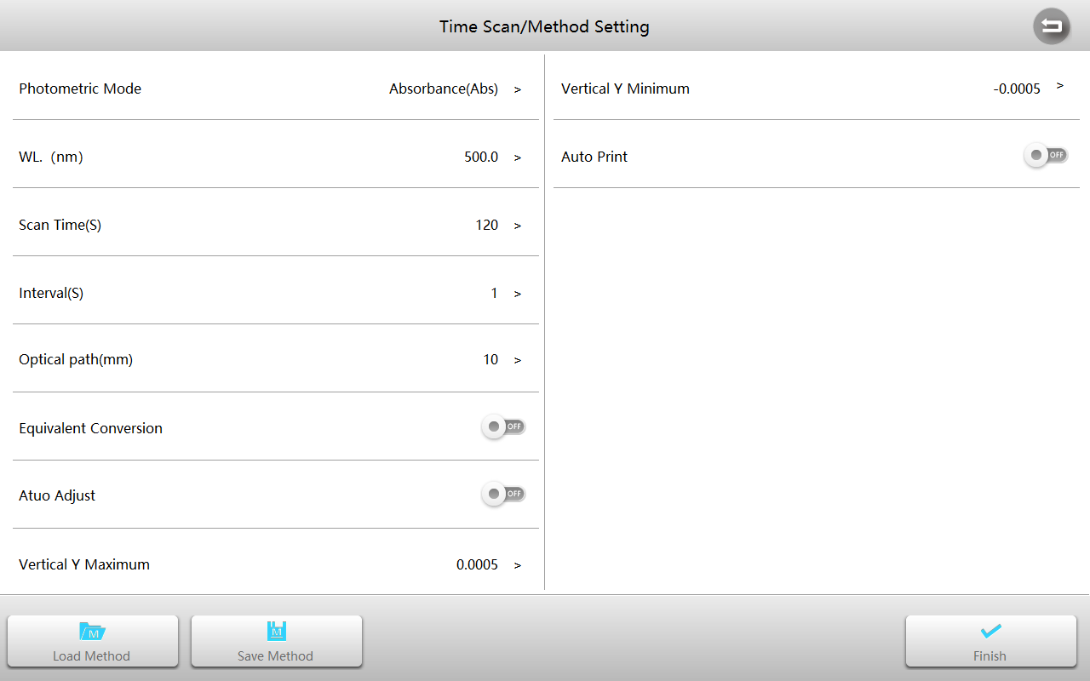
Photometric mode | 3 photometric modes: Abs, %T, %R.
Wavelength | Measurement wavelength, range: 190~1100nm.
Total | Measure the total sampling time required.
Interval | Sampling interval.
Light path length | The width of the cuvette used for the measurement.
Equivalent conversion | Activation automatically converts measurements from different path cuvettes to values in the 10mm light path length.
Auto scale | Whether to automatically adjust the coordinates based on the data.
Y max | The maximum value of the ordinate (valid only when the coordinates are fixed).
Y min | Minimum value of the ordinate (valid only when the coordinates are fixed).
Automatic printing | Automatically print curves and results after measurement is complete.
Automatic save | Automatically save curves and results after measurement is complete.
Put the reference in the measurement channel and reference channel, close the sample chamber cover, and press the button to blank.
Put the sample in the measurement channel, close the sample chamber cover, and press the button to measure the sampled data and draw the curve.
Repeat this process to measure more samples.

Quantitation
Quantitation mode is used to measure sample concentration by establishing and using a standard curve.
Within the Main interface, press the icon  to start a Quantitation application.
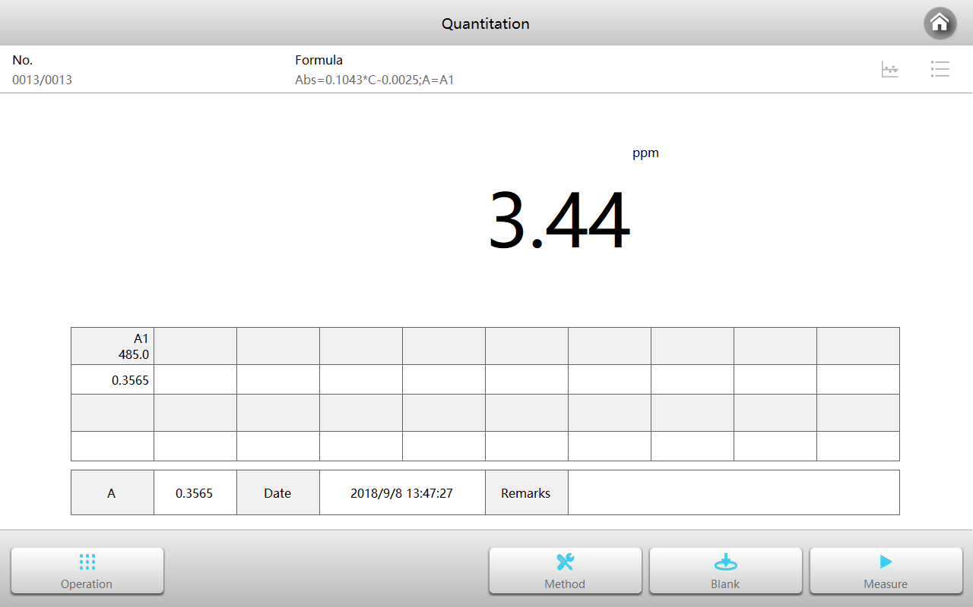

Establish quantitative methods
Press the button to enter the Method interface.
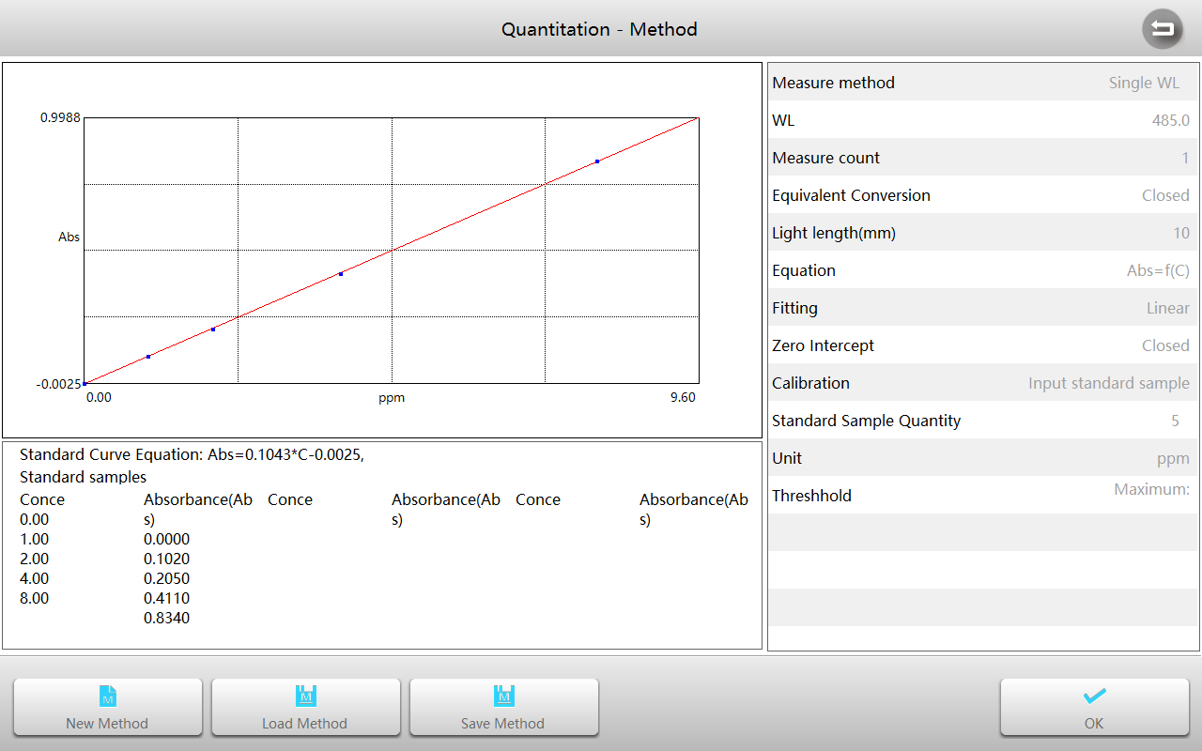
Within the Method interface, press the button to start a new measurement method and enter the parameter setting interface.
Measurement | Built-in single wavelength, dual wavelength difference, dual wavelength ratio, three wavelengths, area 5 ways, and support custom formula.
Wavelength | Measuring wavelength, range: 190~1100nm.
Circle | 1, 2, 3, 5, 10, 20, 30, 50 times can be selected, the instrument will calculate the average as the final output.
Light path length | The width of the cuvette used for the measurement.
Equivalent conversion | Activation automatically converts measurements from different path cuvettes to values in the 10mm light path length.
Equation | Equation form: C=F(Abs) and Abs=F(C).
Fitting | Three ways of fitting are provided: first order, second order, third order.
Zero intercept | Turning on the representative fitting curve will directly cross the zero point, and closing will represent the fitting curve but the zero point.
Calibration | 3 ways to generate a standard curve: input equation coefficient method, standard sample method and input standard sample.
Unit | Built-in 19 commonly used concentration units: -, %, ppm, ppb, g/l, mg/l, μg/l, ng/l, g/dl, mg/dl, μg/dl, mg/ml, μg/ml , ng/ml, μg/μl, ng/μl, mol/l, mmol/l, IU, and support input custom units.
Number of standard samples | The number of standard samples can be selected (only valid for standard sample calibration and standard sample input), quantity: 2~20.
Threshold | Upper and lower limits of measurement results.

Establish standard curve
Select Calibration to Input Equation Coefficient, set the other measurement parameters according to measurement requirements, then press the button to start.
Within the Input Equation Coefficient interface, press the coefficient K0~Kn, use the keyboard to enter the coefficient.
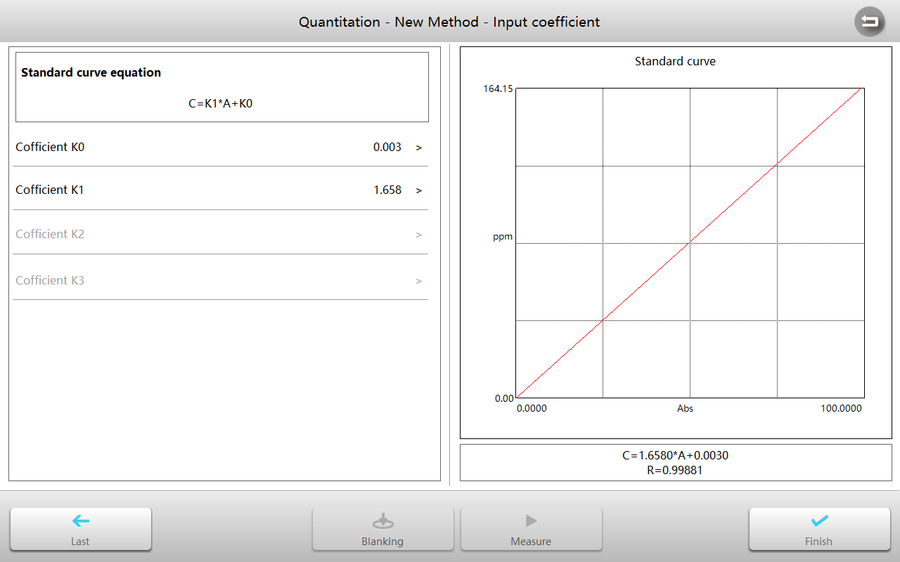
After the method is completed, the standard curve and related information are displayed. Press the button to complete and return to Method interface.
Establish standard curve by measuring standard samples
Set Calibration to Measure standard samples, set other measurement parameters according to measurement requirements, and press the button to start.
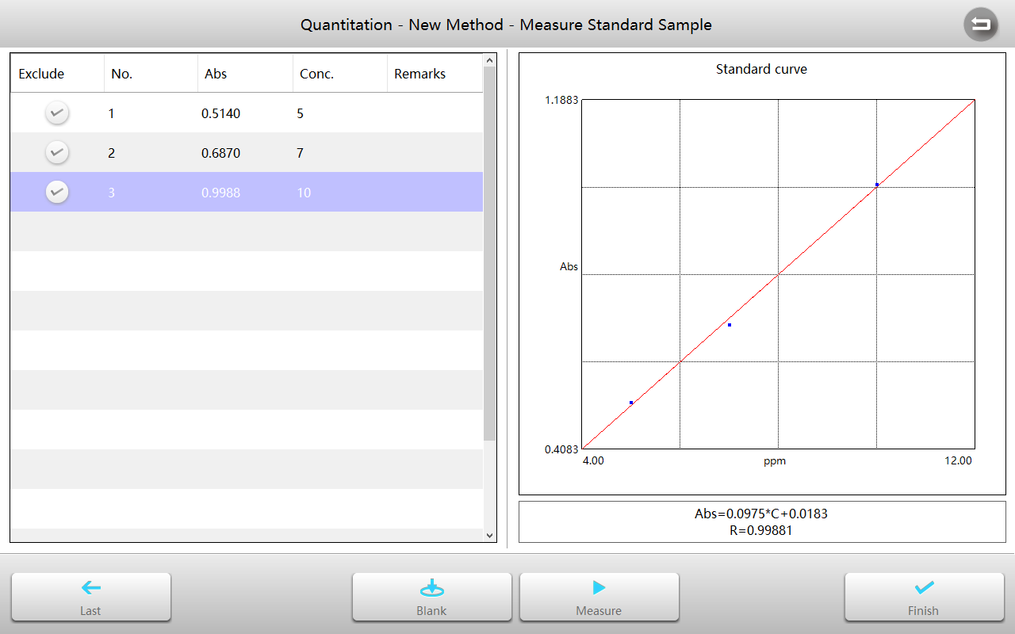
Within the Measure standard sample interface, put the reference in the measurement channel and reference channel, close the sample chamber cover, and press the button to do blank.
Put the standard sample in the measurement channel, close the sample chamber cover, and press the button to measure.
Repeat this process to measure all standard samples.

Press the concentration cell to enter the corresponding concentration value.
After the method is completed, the standard curve and related information are displayed. Press the button to complete and return to the Method interface.
Establish standard curve by measuring standard samples
Set Calibration to Input standard samples, set other measurement parameters according to measurement requirements, and press the button to start.
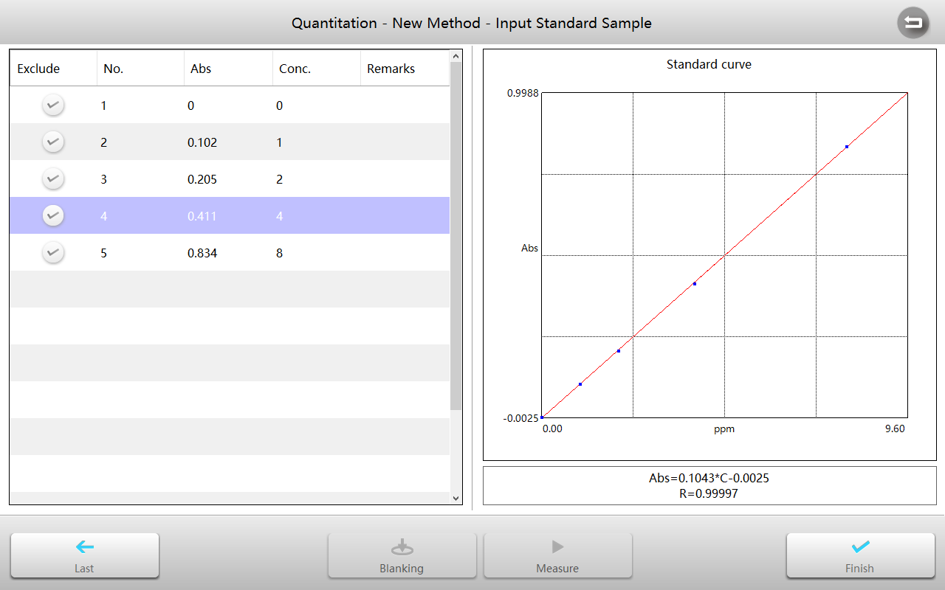
Press the Abs cell to input Abs value and press Concentration cell to input the corresponding concentration value.
After the method is completed, the standard curve and related information are displayed. Press the button to complete and return to Method interface.
Measure sample
Within the Quantitation measurement interface, press the button to enter the Method interface.
With the Method interface, load or select a new method, press the button to accept and return to measurement interface.
Put the reference in the measurement channel and reference channel, close the sample chamber cover, and press the button to do blank.
Put the sample in the measurement channel, close the sample chamber cover, and press the button to measure and calculate results.
Repeat step 4 to measure more samples.
Press to switch to list mode to browse the list of measurement results.

Biological Method
Biological method measurement mode is used to measure DNA, RNA and protein concentrations using built-in methods or new methods.
Within the Main interface, press the icon to start a Biological method measurement application.
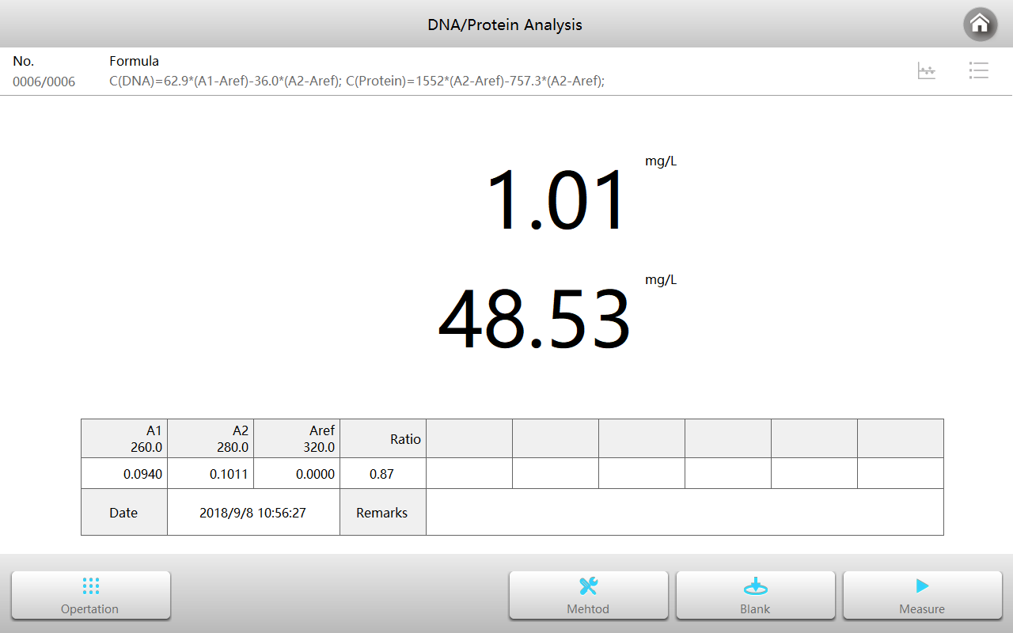
Within the Biological method measurement interface, press the button to open the Method interface.
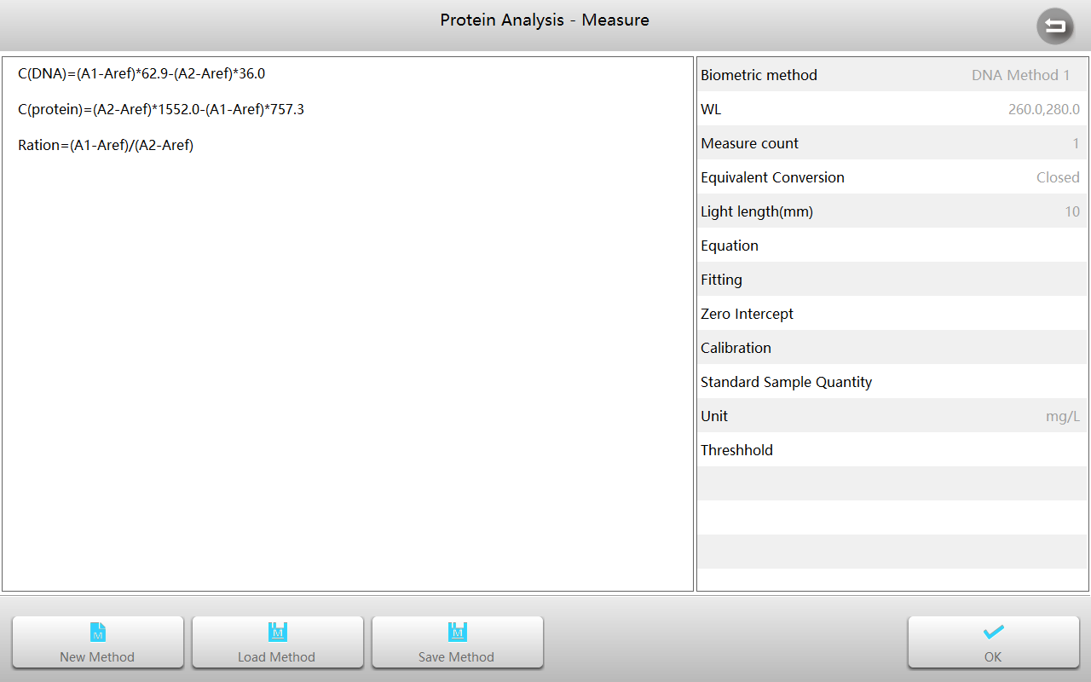
Within the Method interface, press the button to start a new measurement method and enter the parameter setting interface.
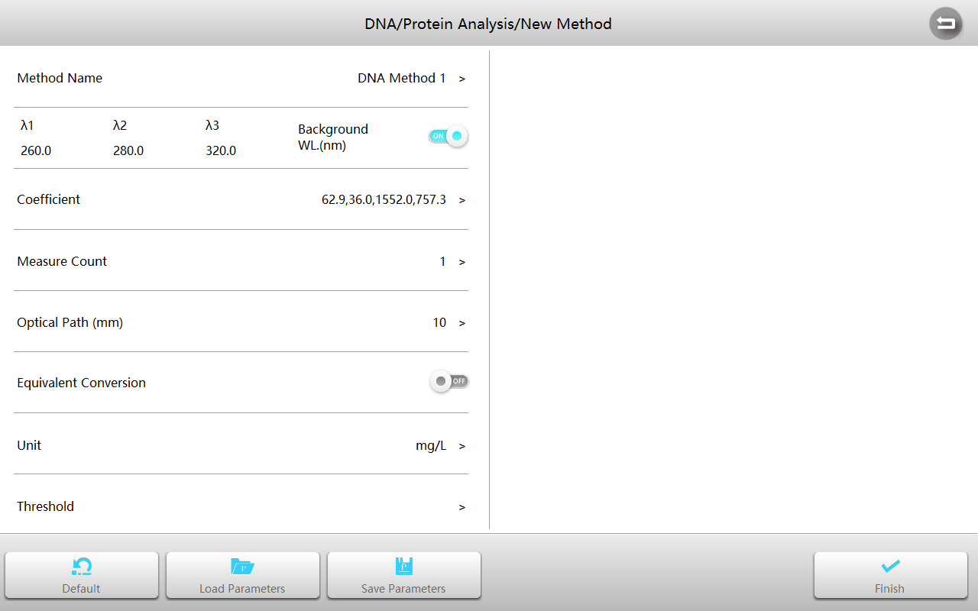
Measurement | Built-in7methods：DNA-1(260/280)，DNA-2(260/230)，UV method，Lowry method，BCA method，CBB method，Biuret method.
Wavelength | Measure wavelength, range: 190~1100nm.
Coefficient | Calculate the coefficient required for concentration (related to the specific measurement method)
Light path length | The width of the cuvette used for the measurement.
Equivalent conversion | Activation automatically converts measurements from different path cuvettes to values in the 10mm light path length.
Unit | Built-in 19 commonly used concentration units: -, %, ppm, ppb, g/l, mg/l, μg/l, ng/l, g/dl, mg/dl, μg/dl, mg/ml, μg/ml , ng/ml, μg/μl, ng/μl, mol/l, mmol/l, IU, and support input custom units.
Threshold | Upper and lower limits of measurement results.
To load or select a new method, press the button to accept and return to measurement interface.
Put the reference in the measurement channel and reference channel, close the sample chamber cover, and press the button to do blank.
Put the sample in the measurement channel, close the sample chamber cover, and press the button to measure and calculate results.
Repeat this process to measure more samples.
Press to switch to list mode to browse the list of measurement results.

Spectrum Scanning
Spectrum scanning mode is used to measure sample concentration by establishing and using a standard curve.
Within the Main interface, press the icon  to start a Spectrum scanning application.
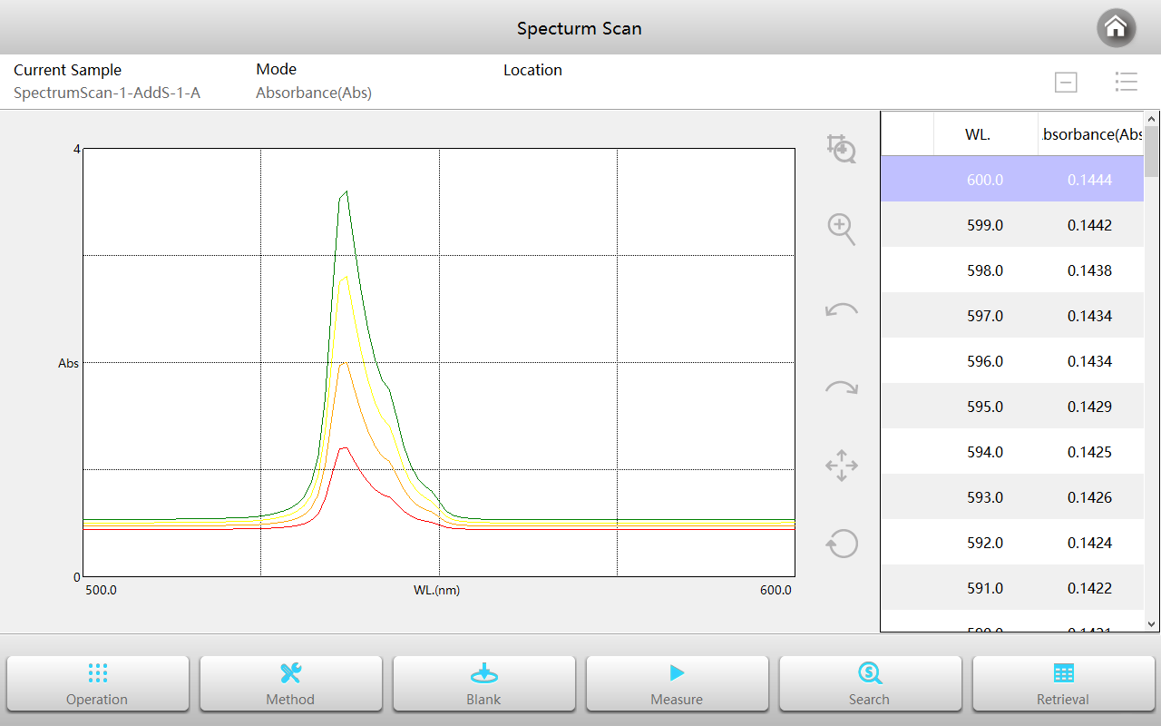
Within the Spectrum scanning interface, press the button to enter the Method interface.
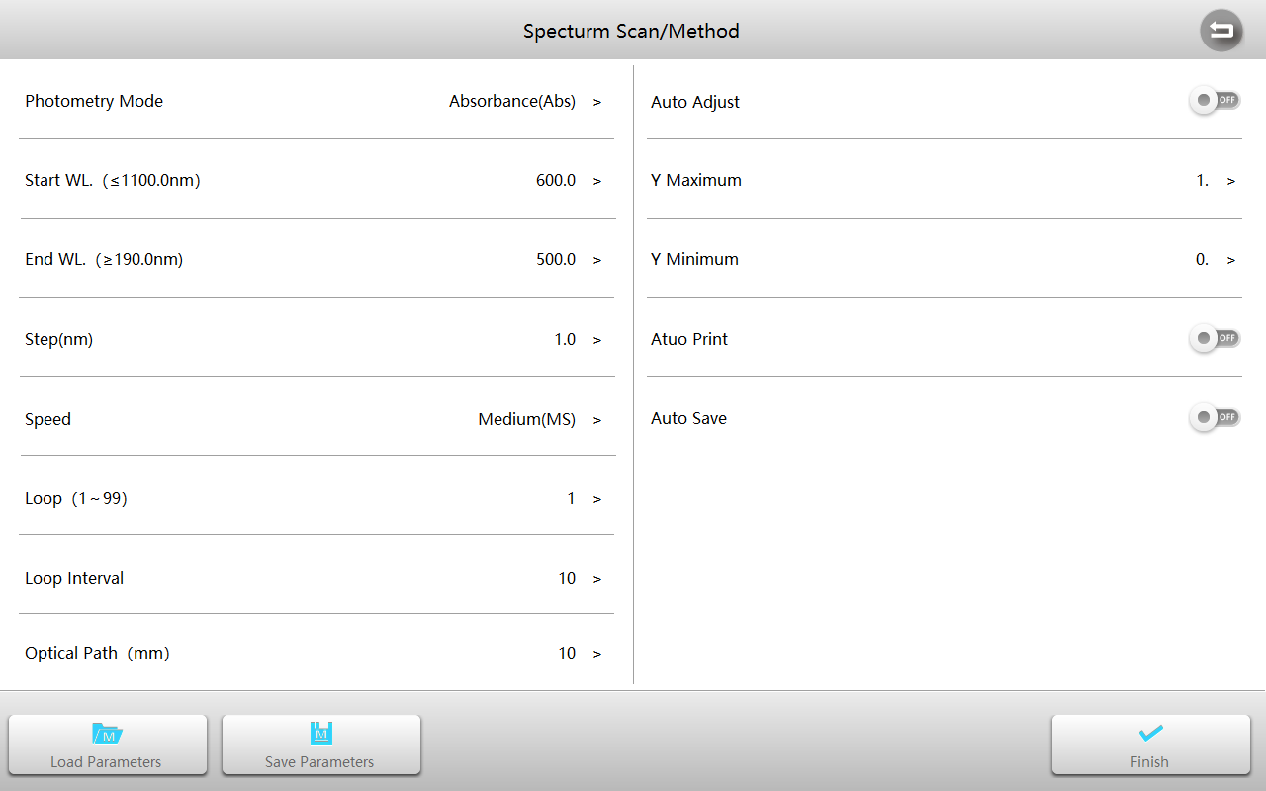
Measurement mode | 3 photometric modes: Abs, %T, %R.
Start wavelength | Scan start wavelength, range: 190~1100nm.
End wavelength | Scan end wavelength, range: 190~1100nm.
Interval | 6 wavelength interval selectable 0.1，0.2，0.5，1.0，2.0，5.0 nm
Speed | 3 scan speed selectable：Quick, Medium, Slow.
Circle | Scan times.
Time interval | Interval between 2 scans.
Light path length | The width of the cuvette used for the measurement.
Auto scale | Whether to automatically adjust the coordinates based on the data.
Y max | The maximum value of the ordinate (valid only when the coordinates are fixed).
Y min | Minimum value of the ordinate (valid only when the coordinates are fixed).
Automatic printing | Automatically print curves and results after measurement is complete.
Automatic save | Automatically save curves and results after measurement is complete.
Put the reference in the measurement channel and reference channel, close the sample chamber cover, and press the button to scan baseline.
Put the sample in the measurement channel, close the sample chamber cover, and press the button to scan sample and draw the curve.
After the scan is complete, press the button to expand the graph as needed.
Press the button to retrieve the value of each point (peak) of the curve and mark it for a specific point.

File management
File management is used to manage saved parameters, methods, and measurement files.
Within the Main interface, press the icon  to start File management.
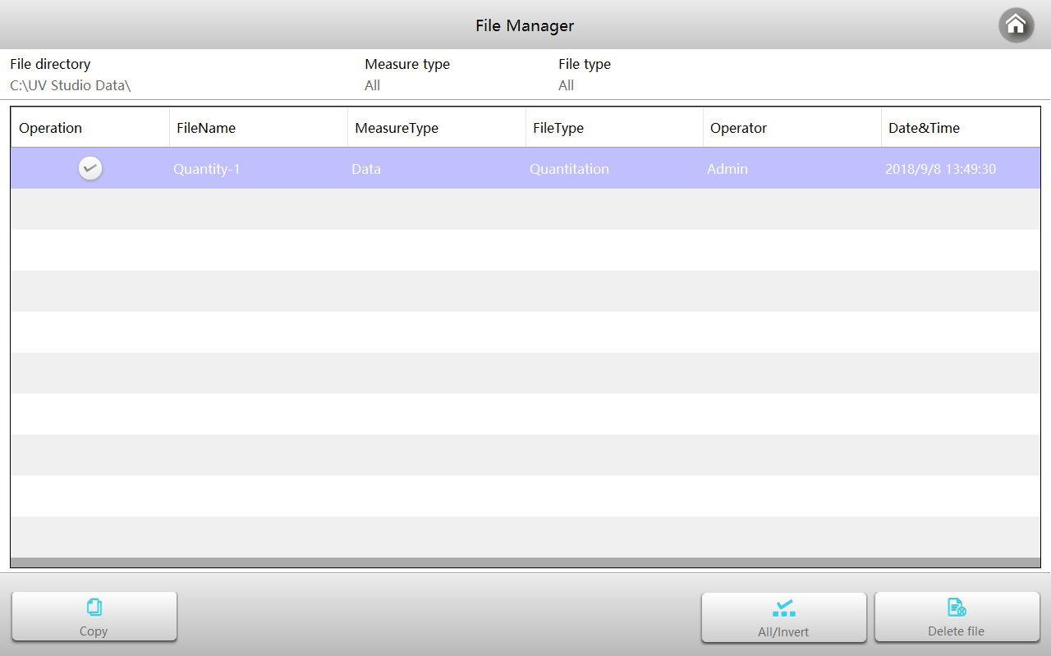
Browse file list
The File management interface displays the data files stored in the storage, including data, methods and parameters. Press Measurement Mode and Type to set the filter conditions and display the corresponding file types.
Delete files
Select the file you want to delete, then press the button to delete it.
Copy files
Select the files you want to copy, then press the button , to use the Path selection form, select the desired target path and press the button .
Rename file name
Press the file name you want to rename, use the keyboard to enter a new file name, and press the button to complete the modification.

User Management and Audit Trail
User management is used to manage user permissions, operation logs, etc.
Within the Main interface, press the icon  to start File management.
Note: Only authorized users can enter the module to perform the corresponding operations.
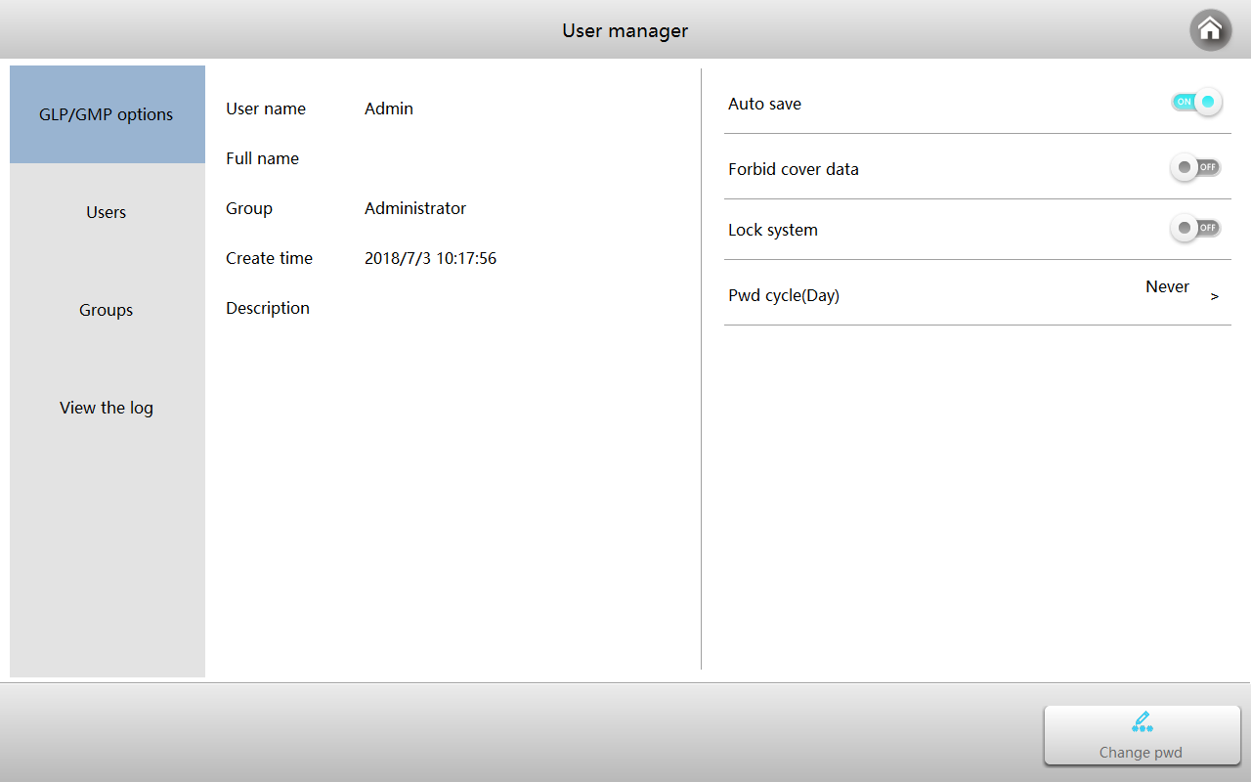
GLP/GMP option
GLP/GMP option contains four GLP/GMP options: “Automatic Data Saving”, “Disable Overwriting Data”, “Allow Locking System” and “Password Replacement Period”, which can be enabled/disabled by the administrator as needed.

Users and user groups
The module is divided into three structural levels; each group is given level specific permissions.
Operation of user groups
Within the User management interface, press the tab Group to enter user group management.
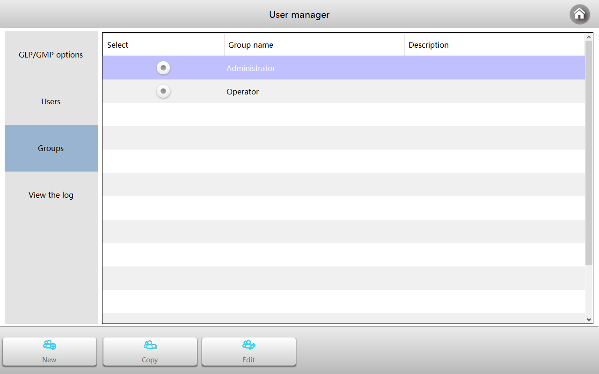
Creating a new user group
Press the button to create a new user group, assign the permissions that the group has, and press the button when done.
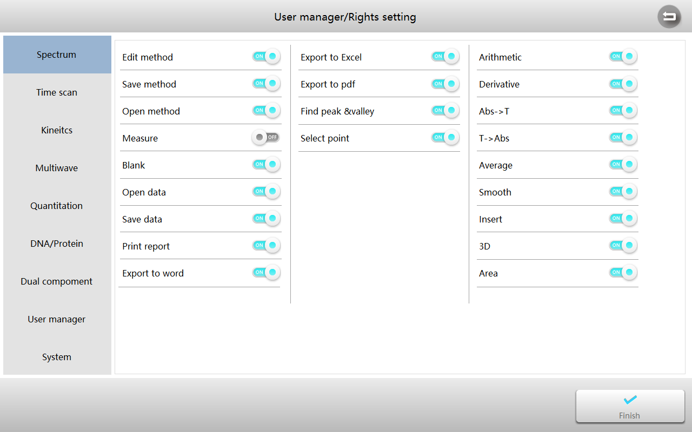
Copy a user group
Select the user group you want to copy, then press the button to copy a user group with the same permissions and press the button to complete.
Edit a user group
Select the user group you want to edit, then press the button to edit the selected group. Press the button to complete.
Operation of user
Within the User management interface, press the tab User to enter user management.
Copy a user
Select the user you want to copy, then press the button to copy a user with the same permissions and press the button to complete.
Edit a user
Select the user you want to edit, then press the button to edit username, description information, password, etc., and press the button to complete.
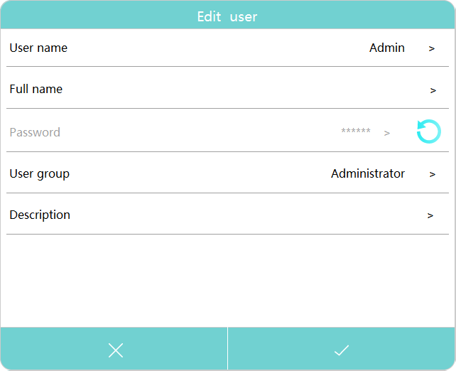
Lock/unlock user
Select the user who needs to lock/unlock, and then press the button to lock the original active user. It will be temporarily unavailable. If you need to re-enable it, select the user to press the button again.
Audit trail
Within the User management interface, press the tab Log to enter log management.
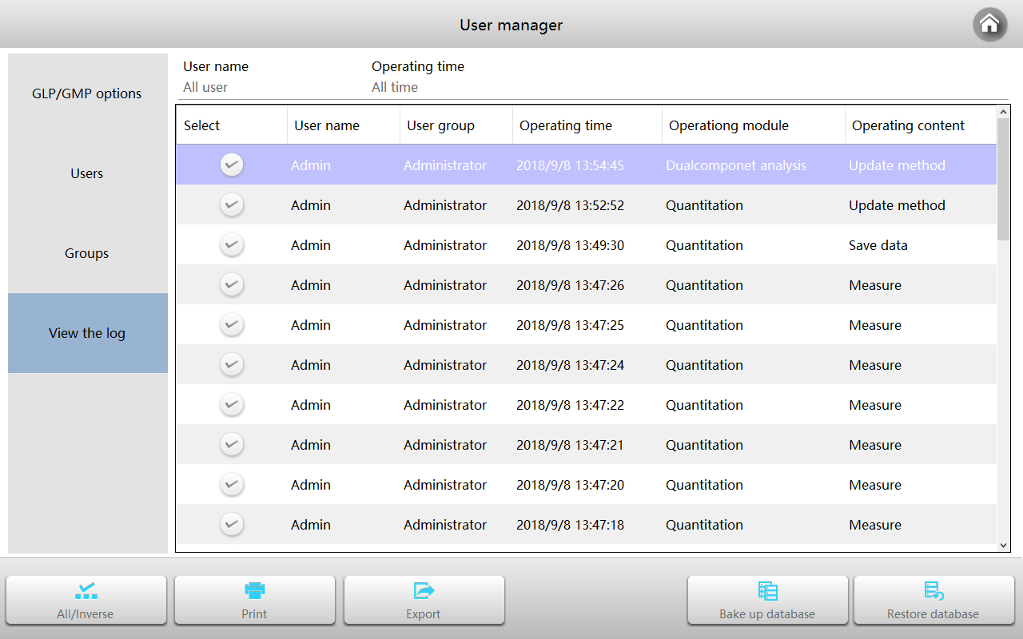
Browse Operation Log
Press Username to select the user who needs to browse the log. Press Operation Time to select the time range for viewing to view the operation log of one (or all) users.
Print Log
Select the log content you want to print and press the button to print the log contents.
Export Log
Select the log content to be printed, press the button , and select the export path to export the log content.
Database Backup
Press the button to back up the database to other storage after selecting the backup path.
Database Recovery
Press the button to select the backed-up database file to restore the database to the instrument default storage location.

Formula Editor
Method editor is used to write formulas for photometric calculations.
Within the Main interface, press the icon  to start Formula editor.
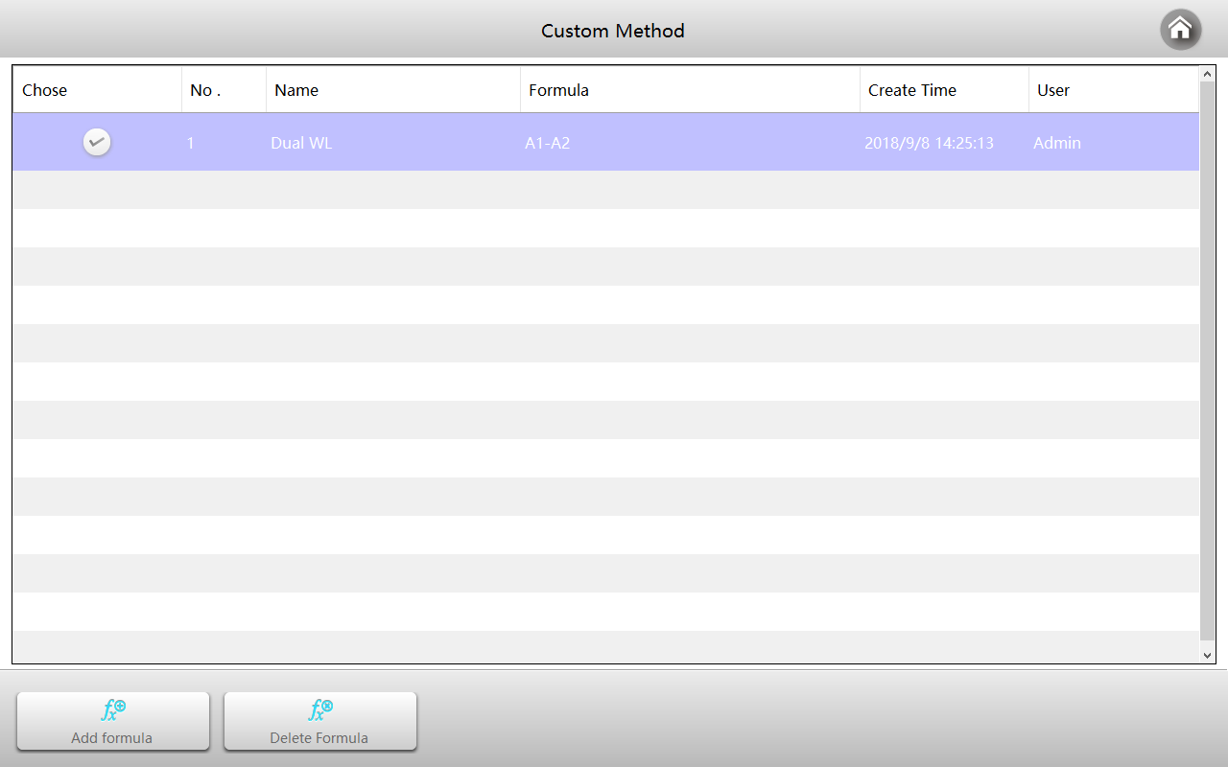
Add calculation formula
Formula list interface, press the button “Add formula” to enter to Formula editor interface. Enter the formula name as required by pressing the label Formula Name, select the applied module, enter the calculation formula and press the button to complete.
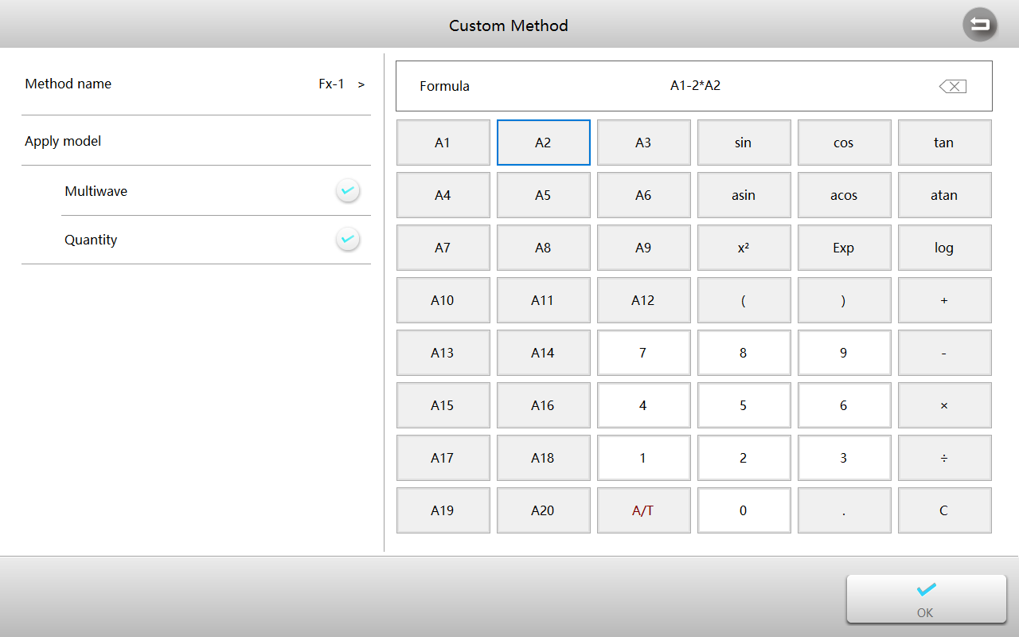
Delete calculation formula
Within the Formula list interface, select the method you want to delete and press the button to delete the method.

Performance Verification
Performance verification is used to verify that the instrument's performance indicators are good.
Within the Main interface, press the icon  to start Performance verification.
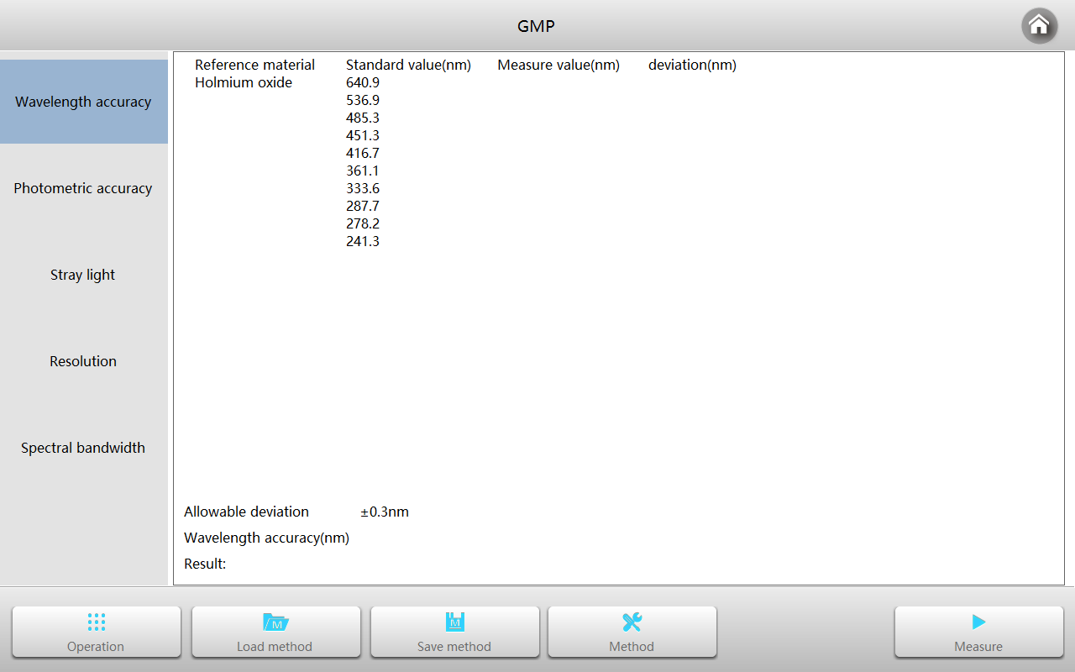
Preparing
The instrument must be warmed up for more than 30 minutes prior to performing performance verification, allow the instrument to calibrate the dark current and system baseline. The reference material used for verification must be within the validity period of the test.

Wavelength accuracy and wavelength repeatability verification

Standard material
Please use a Holmium oxide solution or equivalent filter.
Verification
Within the Performance Verification interface, press the tab Wavelength Accuracy，and press the Method button to enter the Setting interface, set the desired parameters, and press the button to accept.
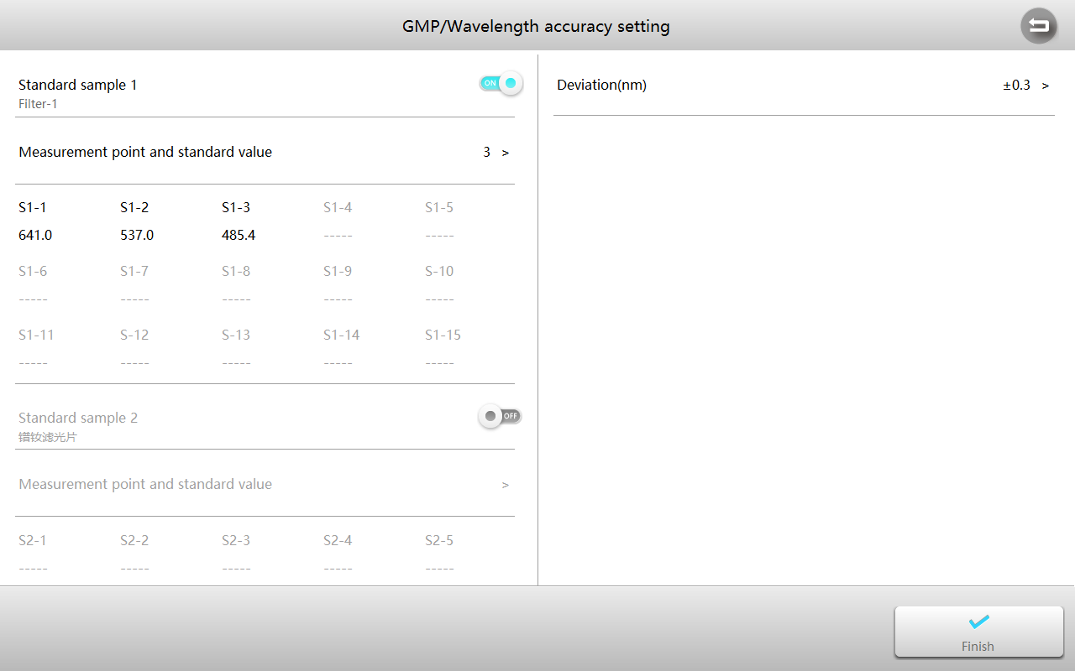
Clear the measurement channel, close the sample chamber cover, press the button and select the tab Wavelength Accuracy to start the measurement.
Put the reference into the measurement channel to blank, then put the standard material into the measurement channel and display the test result after completion.
Photometric accuracy and photometric repeatability verification

Standard material
Please use NIST 930D or equivalent filter.
Verification
Within the Performance Verification interface, press the tab Photometric Accuracy，the press the Method button to enter the Setting interface, set parameters, and press the button to accept.
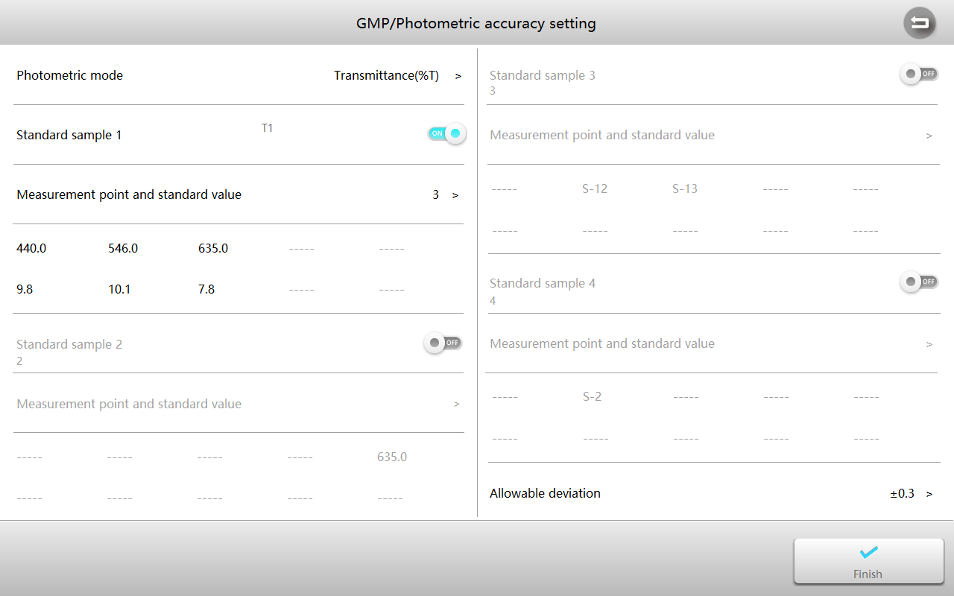
Remove samples from the measurement channel, close the sample chamber cover, press the button and select the tab Photometric Accuracy to start the measurement.
Put the reference into the measurement channel to blank, then put the standard material into the measurement channel and display the test result after completion.
Stray light verification

Standard material
Please use 10g/L NaI solution or equivalent filter (220nm), 50g/L NaNo₂ solution or equivalent filter (340 or 360nm)。
Verification
Within the Performance Verification interface, press the tab Stray Light，and press the Method button to enter the Setting interface, set parameters, and press the button to accept.
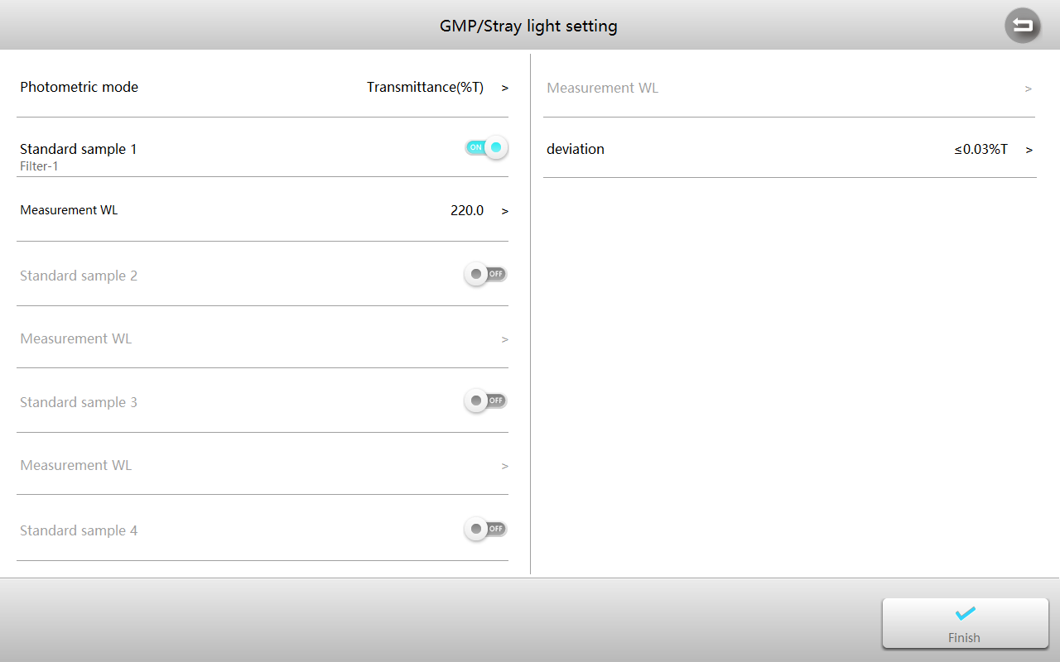
Remove anything in the measurement channel, close the sample chamber cover, press the button and select the tab Stray Light to start the measurement.
Put the reference into the measurement channel to blank, then put the standard material into the measurement channel and display the test result after completion.
Resolution verification

Standard material
Please use Toluene-hexane.
Verification
Performance Verification interface, press the tab Resolution，and press Method button to enter the Setting interface, set parameters, and press the button to accept.
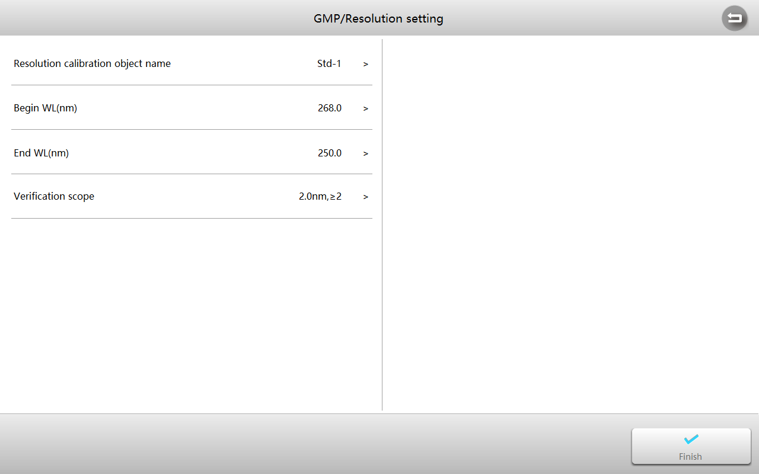
Remove anything in the measurement channel, close the sample chamber cover, press the button and select the tab Resolution to start the measurement.
Put the reference into the measurement channel to blank, then put the standard material into the measurement channel and display the test result after completion.

Repair and Maintenance
Daily maintenance of the instrument is necessary to maintain optimal working condition. Please see below for maintenance procedures.

Daily Maintenance
Check the Sample Compartment
After each measurement, promptly remove the cuvettes containing sample solutions from the compartment. If left inside, evaporation may cause condensation and lead to mold formation on the optical mirrors.
Pay special attention when using corrosive or highly volatile samples. Immediately wipe off any spilled or residual liquid inside the compartment using a soft, lint-free cloth.
Clean the Instrument Surface
The instrument cover is coated with protective paint. Wipe any spills or drips from the surface immediately using a damp cloth.
Do not use organic solvents or abrasive cleaners, as these may damage the finish. Clean any dirt or residue from the cover regularly to maintain the instrument’s appearance and durability.
Clean the Cuvettes
After each measurement or whenever the sample solution is changed, carefully clean the cuvettes. Residual liquid or contamination on the cuvette surfaces can cause measurement errors. Ensure the cuvettes are completely dry before reuse or storage.

Troubleshooting

Problem | Cause | Solution
Power on, no response | Power cord connection is not reliable | Improve connectivity
Power on, no response | Fuse burning | Replace fuse
Measurement uncertainty | Sample is not Stable | Improve the sample
Measurement uncertainty | Glass cuvettes used in UV Range | Use quartz cuvettes
Measurement uncertainty | The concentration of sample is too high | Diluted sample
Measurement uncertainty | Power Supply Voltage Low or not Stable | Improve the Power Supply
Measurement uncertainty | Lamp damage or lamp life maturity | Replace lamp
Dark Current Error when self-check | The lid of the compartment is open  during self-check | Close the lid, restart
System Calibrate Failed | Something blocks the Light path | Remove it, calibrate again
Measurements inaccurate | Cuvettes were contaminated | Clean cuvettes
Measurements inaccurate | Samples were contaminated | Improve samples
Measurements inaccurate | Worse matching of the cuvettes | Improve the matching of the cuvettes
Measurements inaccurate | Dark current error | Resample dark current

Spare Parts Replacement

Replace the fuse
Danger! Be sure to switch off the power and unplug the socket before replacement!
Tools preparation
Prepare a 3×75 Flat Blade screwdriver.
Switch Off the power supply
Switch off the power supply and unplug the socket.
Take out the Fuse Seat
Use a screwdriver to pry open the fuse holder.
Replace a new fuse
Pick out the spare fuse (position 1) and replace it with position 2. Install the fuse holder back to the instrument power outlet.
Power on: Plug in the socket and switch on the power.

Warranty
We warrant that this product is free from defects in materials and workmanship for a period of one (1) year from the date of delivery. If a defect is found during this period, we will, at our discretion and expense, repair the product, replace it, or refund the original purchase price, provided the product is returned within the warranty period.
This warranty does not apply to products that have been damaged as a result of accident, abuse, misuse, improper application, or normal wear and tear. Failure to perform the required maintenance or inspection services in accordance with the operating manual or applicable local regulations will render this warranty void, except where the defect is proven to be unrelated to such non-performance.
Products returned under warranty must be properly insured by the customer against loss or damage during shipment. This warranty is limited to the remedies specified above. IT IS EXPRESSLY AGREED THAT THIS WARRANTY IS IN LIEU OF ALL OTHER WARRANTIES, WHETHER EXPRESS OR IMPLIED, INCLUDING ANY WARRANTY OF MERCHANTABILITY OR FITNESS FOR A PARTICULAR PURPOSE.


Compliance with Local Laws
The customer is responsible for applying for and obtaining the necessary regulatory approvals or other authorizations necessary to run or use the Product in its local environment. WE will not be held liable for any related omission or for not obtaining the required approval or authorization, unless any refusal is due to a defect of the product.
Equipment Disposal

This equipment is marked with the crossed-out wheeled bin symbol, indicating that it must not be disposed of with unsorted municipal waste.
At the end of its service life, it is your responsibility to ensure proper disposal by delivering the equipment to an authorized collection or recycling facility.
If the equipment has been exposed to biological, chemical, or radiological materials, it must be decontaminated prior to disposal to protect the health and safety of personnel handling recycling and waste processing.
For information on authorized collection points or recycling options, please contact your local distributor or dealer from whom the equipment was purchased.
By disposing of this equipment responsibly, you are helping to conserve natural resources and protect human health and the environment.
Thank you for your cooperation.


609.642.6840 | info@mpdscientific.com
www.mpdscientific.com
Copyright ©2025 MPD Scientific Inc.

