SP3000/SP3000UV/SP4000/SP4000UV Spectrophotometer
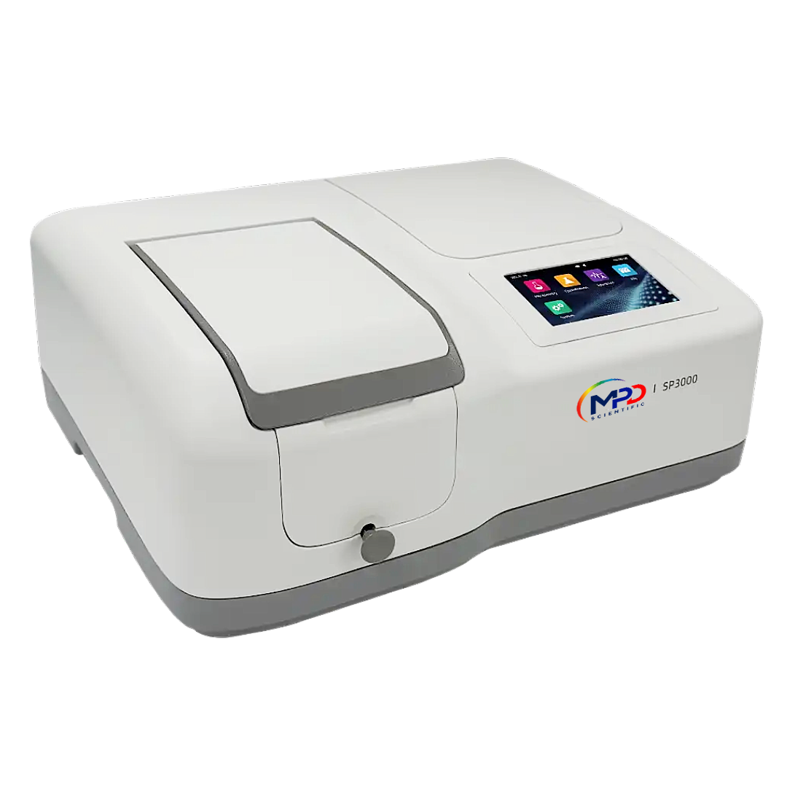
Instruction Manual
 |  |  |  |  |  |  |  | 
PN : 435058 |  |  |  |  |  |  | Version : 1.0.1

Table of Contents
Safety Information 1
Package Contents 1
Unpacking 1
Installation 2
Symbols and Conventions 2
Specifications 3
Overview 4
Description of Buttons and Switches 4
Getting Started 4
General Operating Instructions 5
Touch Screen Using Tips 5
Select Application 5
Basic Operation 6
Measurement Results Operation 6
Files Operation 8
Calibration and System Settings 9
Calibration 9
Settings of Light Source 10
Edit Clock 11
Memory Management 11
Language Selection 12
General Options 12
Restore Defaults 13
Performance Verification 14
Verifying Wavelength Accuracy and Wavelength Repeatability 错误！未定义书签。
Verifying Photometric Accuracy and Photometric Repeatability 错误！未定义书签。
Verifying Stray Light 错误！未定义书签。
Verifying Noise 错误！未定义书签。
Verifying Dark Noise 错误！未定义书签。
Verifying Stability 错误！未定义书签。
Verifying Bandwidth 错误！未定义书签。
Measurement 14
Important Guidelines 16
Check the cuvettes 16
Photometry 16
Quantitation 18
Spectrum 22
Troubleshooting 25
Repair and Maintenance 25
Daily Maintain 25
Spare Parts Replacement 26
Warranty 29
Equipment Disposal 30

Safety Information
Please read this manual thoroughly before operating the unit.
Follow all safety and operating guidelines to ensure proper use of the instrument.
Do not open the device.
Always disconnect the device from the main power supply before performing any maintenance or replacing fuses.
Danger: High voltage inside the device. Risk of electric shock.
Do not use the device if it is damaged, especially if the main power cable is frayed, cut, or defective.
Repairs must only be performed by authorized service technicians from your local MPD Scientific office or approved service partners.
Ensure the device is connected to a properly grounded power outlet.
Using the equipment in a manner not specified by the manufacturer may impair the protective features of the instrument.
Prevent liquids from entering the device.
Do not operate the device in hazardous or potentially explosive environments.
Package Contents
Description | Quantity
Spectrophotometer | 1PC
Glass Cuvette | 4PCS
Quartz Cuvette (UV/Visible models only) | 2PCS
Power Cord | 1PC
Instruction Manual | 1PC
Dust Cover | 1PC
Unpacking
After opening the package, carefully check the contents against the packing list. If any items are missing or damaged, please contact your local MPD Scientific office or an authorized service partner immediately.

Installation
Placement
Place the instrument carefully on a stable, level surface to ensure proper operation and to prevent vibration or accidental movement.
Connecting the Power Cord
Before connecting, make sure the instrument’s power switch is turned off.
Insert the female end of the power cord into the instrument’s power inlet, then plug the male end into a properly grounded power outlet.

Symbols and Conventions
The following chart is an illustrated glossary of the symbols that are used in this manual.
 | CAUTION Indicates a potential risk and alerts the user to proceed with caution.
 | HIGH VOLTAGE Warns of the presence of high voltage. Follow all safety procedures to avoid electric shock.
 | HOT SURFACE Indicates a risk of burns due to hot surfaces. Avoid contact during or after operation.

Specifications
Model | SP3000 | SP4000 | SP3000UV | SP4000UV
Optical system | Single beam，1200 l/mm grating
Light source | Tungsten lamp |  | Tungsten lamp，Deuterium lamp
Detector | Silicon photodiode
Spectral bandwidth | 4 nm | 2 nm | 4 nm | 2 nm
Wavelength range | 315~1100 nm |  | 190~1100 nm
Wavelength accuracy | ±0.5 nm
Wavelength repeatability | ≤0.2 nm
Wavelength resolution | 0.1 nm
Wavelength swing speed | 6000 nm/s
Wavelength scanning speed | 25~4200 nm/s
Photometric range | -0.3~3 A，0~200 %T，0~9999.9 C
Photometric accuracy | ±0.002 A（0~0.5 A），±0.004 A（0.5~1 A）, ±0.5 %T（0~100 %T）
Photometric repeatability | ±0.001 A（0~0.5 A），±0.002 A（0.5~1 A）, ±0.2 %T（0~100 %T）
Stray light | ≤0.05 %T（360 nm） |  | ≤0.05 %T（220 nm， 360 nm）
Noise | ≤0.0005 A @ 0 A，500 nm，≤0.001 A @ 1 A，500 nm，≤0.002 A @ 2 A，500 nm
Baseline flatness | ±0.002 A
Sample charger | 10 mm 4-cell manual charger
Display | 5 inch TFT color touch screen
Storage | 236 KB (built-in), supports unlimited external expansion (USB memory)
Interface | RS232 serial port × 1 (printer), USB-A × 1 (USB memory/USB printer), USB-B × 1 (computer)
Power supply | 100~240 V AC，50~60 Hz，75 W |  | 100~240 V AC，50~60 Hz，120 W
Size | 456（W）×360（D）×185（H） mm
Weight | 10.5 kg |  | 10.7 kg

Overview
The SP3000 / SP4000 / SP3000UV / SP4000UV Spectrophotometers are versatile analytical instruments designed for precise photometric and wavelength measurements across a wide range of laboratory and industrial applications. These instruments are commonly used in chemistry, pharmaceuticals, biochemistry, metallurgy, light industry, textiles, materials science, environmental testing, medical research, and education, particularly in quality control and research laboratories.

Description of Buttons and Switches

Front View
Right View
Rear View

Getting Started
The following steps outline the basic operation of the instrument.

Power On and Self-Check
- Switch on the power.
After the instrument is powered on, it will automatically perform a self-check sequence to ensure proper operation.
- Self-check procedures include:
  - Lamp ignition
  - Filter disc positioning
  - Automatic sample holder positioning (if installed)
  - Dark current acquisition
  - Wavelength calibration
  - Energy verification
  - System baseline check
Once the self-check process is complete, the instrument is ready for measurement.
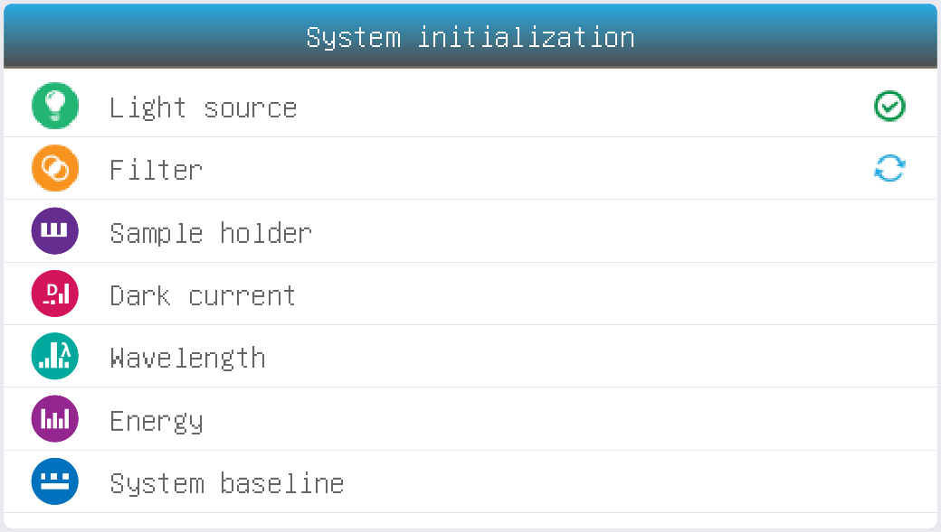

General Operating Instructions
Touchscreen Operation
The instrument is equipped with a full-color touchscreen that allows easy operation through direct touch.
To select an option, gently press the desired area of the screen using your fingertip, fingernail, or a stylus.
Avoid using sharp objects such as ballpoint pens or metal tools, as these may damage the screen surface.
Selecting an Application
From the Main Interface, touch the corresponding icon to open and begin the desired application.
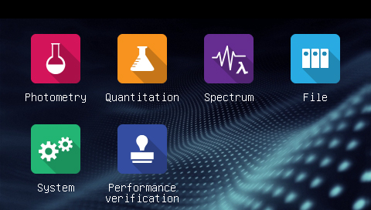
Photometry Measure the absorbance or transmittance of the sample.
Quantitation Establish the standard curve and measure the concentration of the sample.
Spectrum Scan the sample in a wavelength range.
File Manage files stored in the instrument or USB disk.
System calibration and setup.
Performance verification Verify the performance of the instrument.
Basic Operation
 | Home Back to main interface.
 | Return to the previous interface.
/ | Page Up/Down Go to previous/next page.
Measurement Results Operation
Open result(s) from internal/USB memory.
Save result(s) to internal/USB memory.
Print result(s).
Delete selected result(s).
Rename, Print and Delete Results
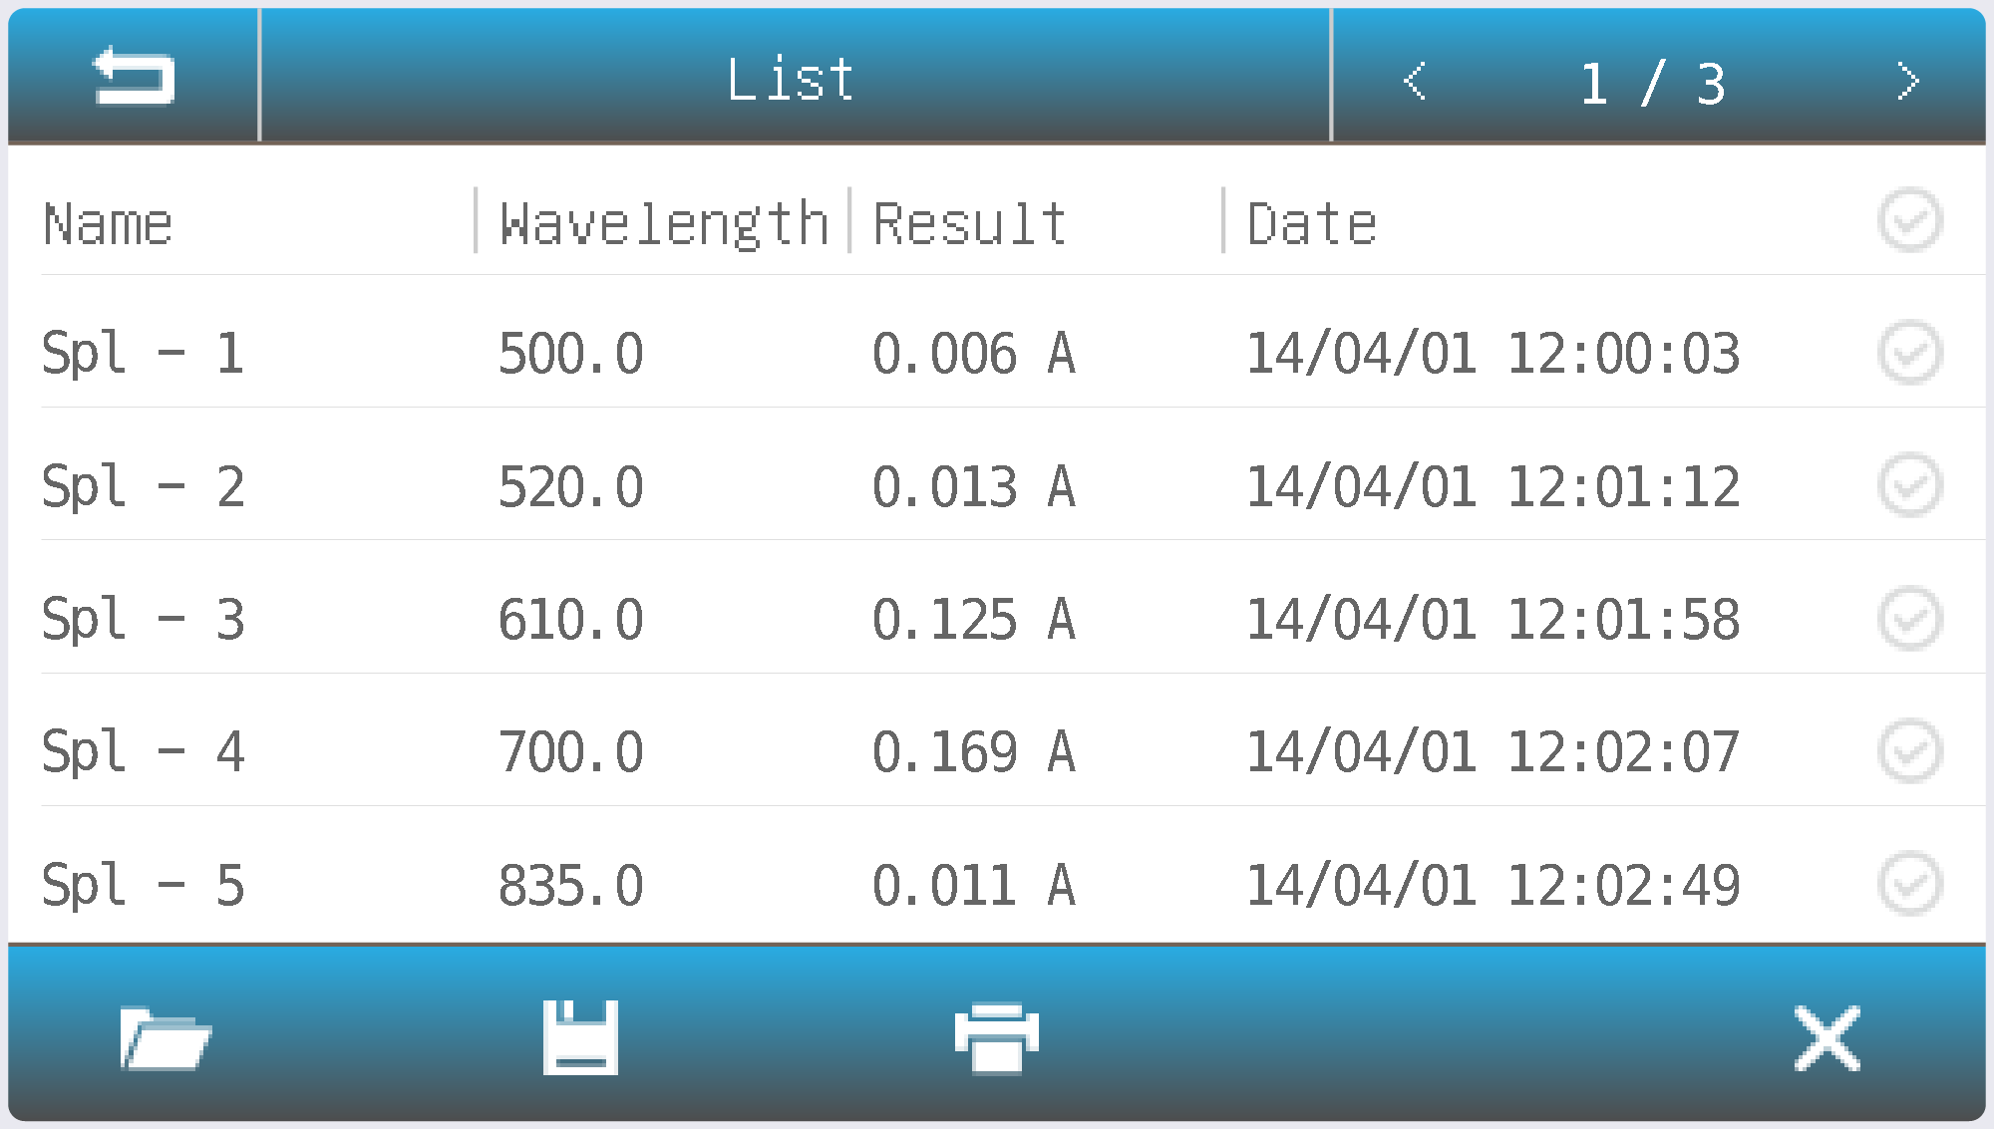
Rename a Sample: | In the list interface, tap the Name field of the desired sample. Enter a new sample name (up to 8 characters) using the on-screen keyboard.
Print the Measurement Report: | In the list interface, tap the Print icon to generate and print the measurement report.
Delete sample(s): | Select the desired sample(s) by checking the corresponding box. Tap the Delete icon to remove the selected record(s).
Open Results
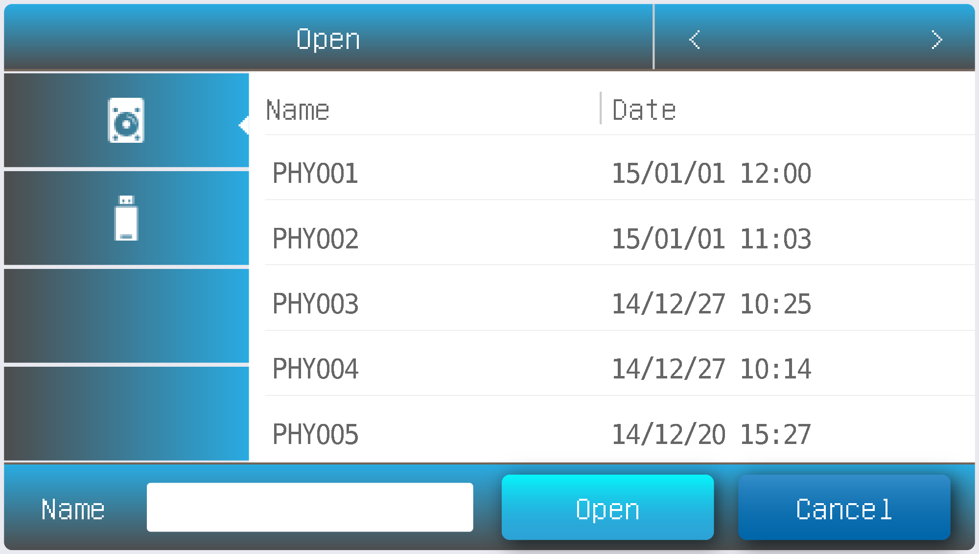

Open: | In the list interface, press the icon .  Select the storage location by tapping Internal Memory or USB Memory, depending on where the file is saved. From the file list, choose the desired file, then tap Open to load it.

Save Results
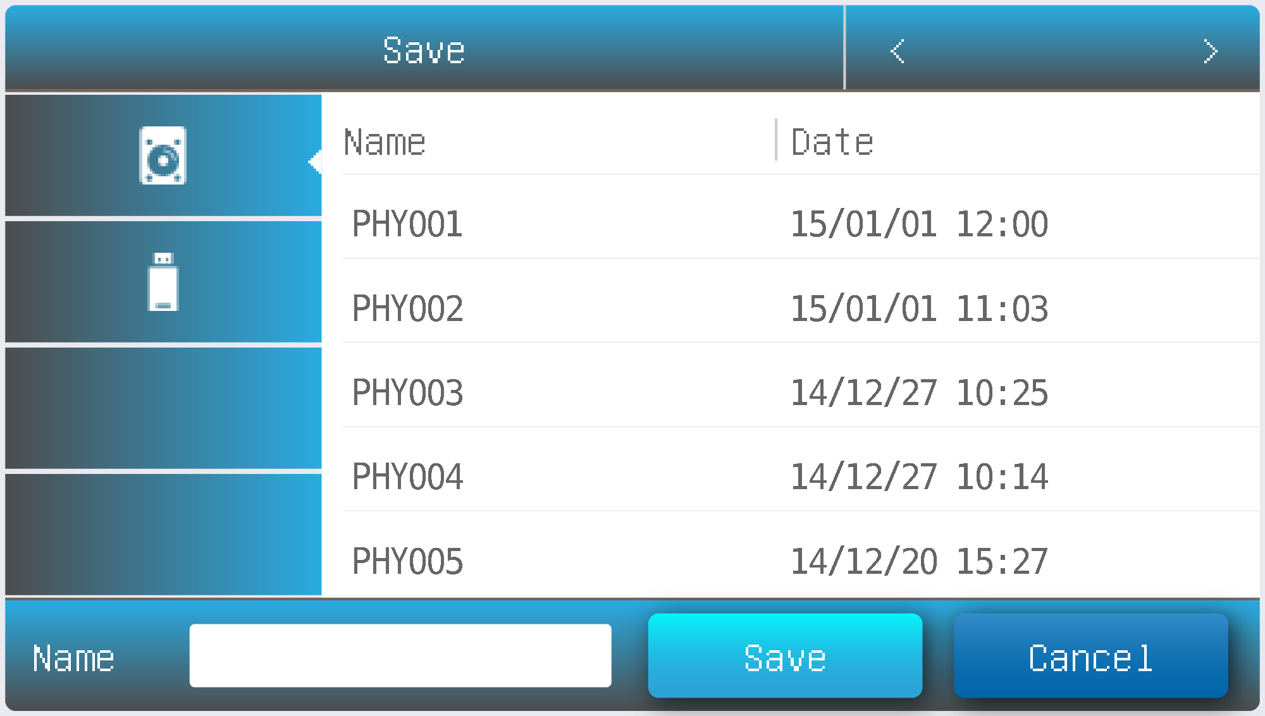
Save: | In the list interface, press the icon Save.  Press the icon / to select the Internal/USB where the file is saved.  Type in the file name, press the button Save.
Files Operation
Internal Memory Internal memory of the spectrophotometer.
USB Memory USB extended mass memory.
Copy the cselected file(s) from internal /USB memory to USB/internal memory.
Export csv Export file(s) to *.csv format
Export txt Export file(s) to *.txt format
Delete the selected file(s).
Rename, Import, Export and Delete Files
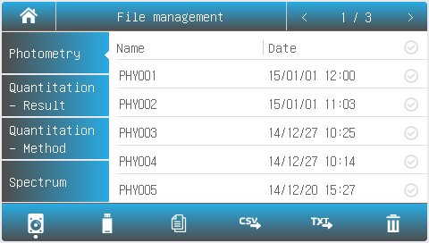
Rename a File: | In the file management interface, tap the Name field of the desired file. Enter a new file name (up to 8 characters) using the on-screen keyboard.
Copy File(s) From/To Internal Memory/USB Memory: | In the File management interface, press the Check Box, press the button （USB Disk required）.
Export File(s) To *.csv Format | In the File management interface, press the Check Box, press the button （USB Disk required）.
Export File(s) To *.txt Format | In the File management interface, press the Check Box, press the button （USB Disk required）.
Delete File(s): | In the File management interface, press the Check Box, and press the icon .

Calibration and System Settings
Select the icon in the main interface. It will display options to calibrate the system and configure basic instrument settings.
Calibration
Calibrate: Begin calibration sequence.
Select Tab Calibration in the System interface. Ensure that all samples are removed from the measurement channel. Close the sample chamber cover securely. Select one of the following calibration options to perform the desired calibration procedure: Wavelength Calibration, System Baseline Calibration, Dark Current.
Confirm your selection by pressing the icon.

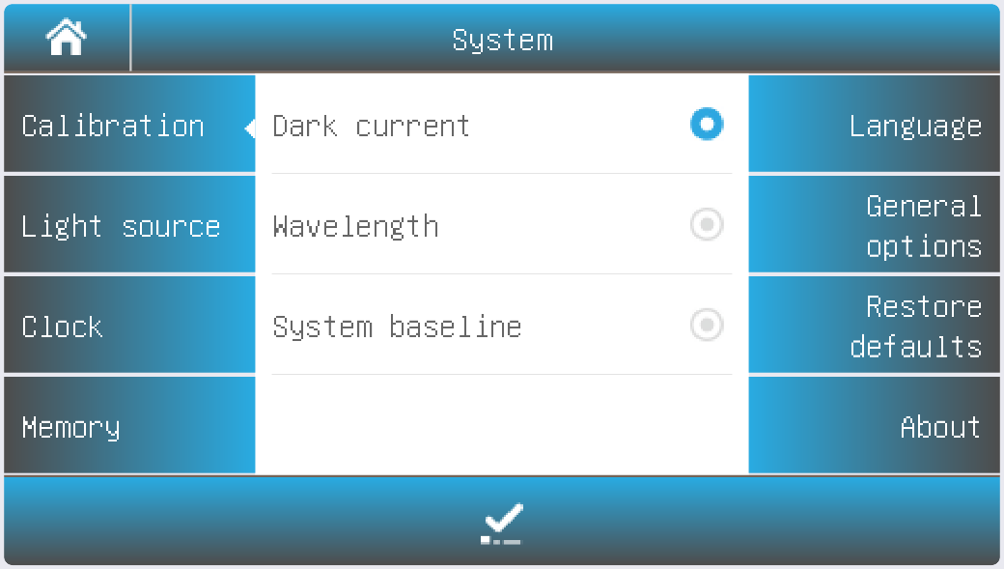
Settings of Light Source
 | Tungsten Lamp Reset
 | Deuterium Lamp Reset
Select Tab Light source in the System interface. The light source information is displayed on the screen.
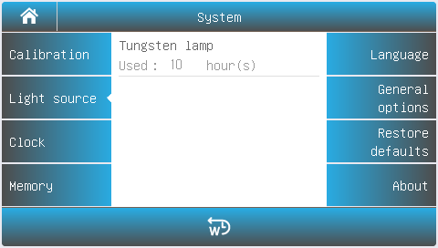
Visible models
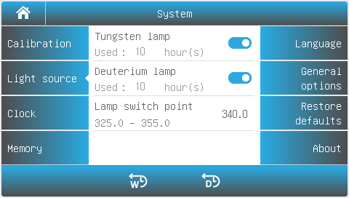
UV/VISIBLE models
Turning Lamps On/Off:
Press the lamp icon to turn the Tungsten or Deuterium lamp on or off.
Changing Lamp Switching Point:
Press the current lamp switching point value and enter the new value.
Resetting Lamp Usage:
Press the corresponding icon / to reset the usage time for the Tungsten or Deuterium lamp.

Important information
To conserve energy, turn off the unused light source if only one lamp will be used for an extended period.
After changing the lamp switching point, the system baseline must be recalibrated.

Editing the Clock:
- Open the System interface and select the "Clock" tab.
- Press the value for year, month, date, hour, minute, or second to change it.
- Press the accept icon to save the new value.
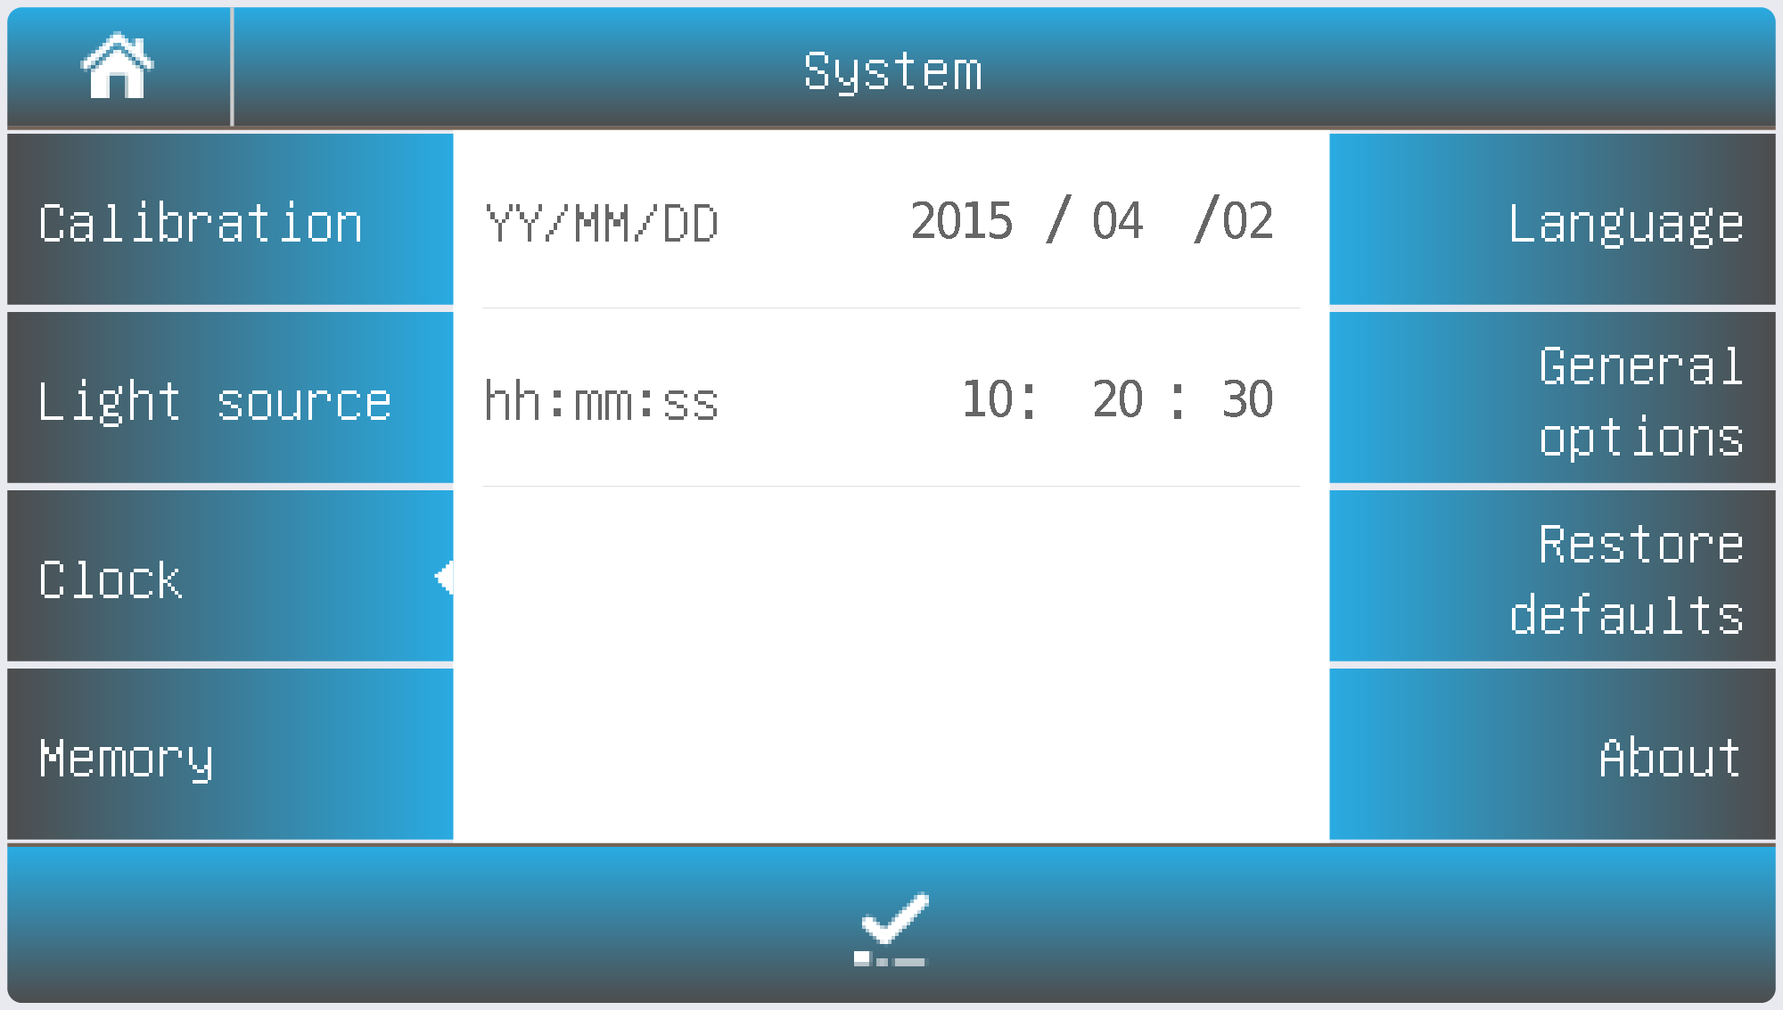
Memory Management
Format Internal Memory.
Format USB Memory storage.
Select the Memory tab in the System interface to view the status of the internal memory and any inserted USB memory. Press the corresponding icon to format either the internal memory or the USB memory.

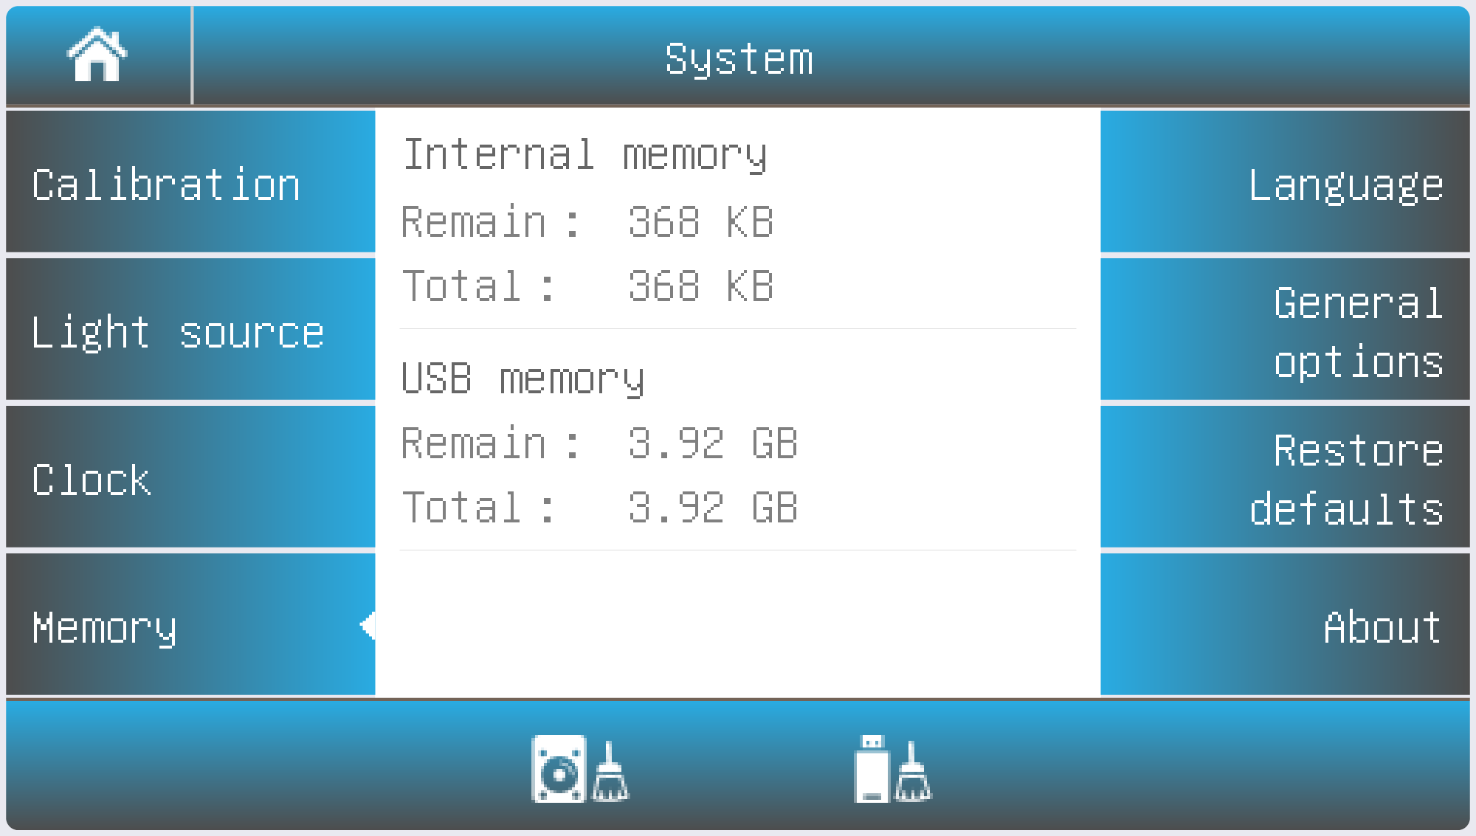
Language Selection
Accept the new language.
Select Tab Language in the System interface. Select a language, press the icon to change.
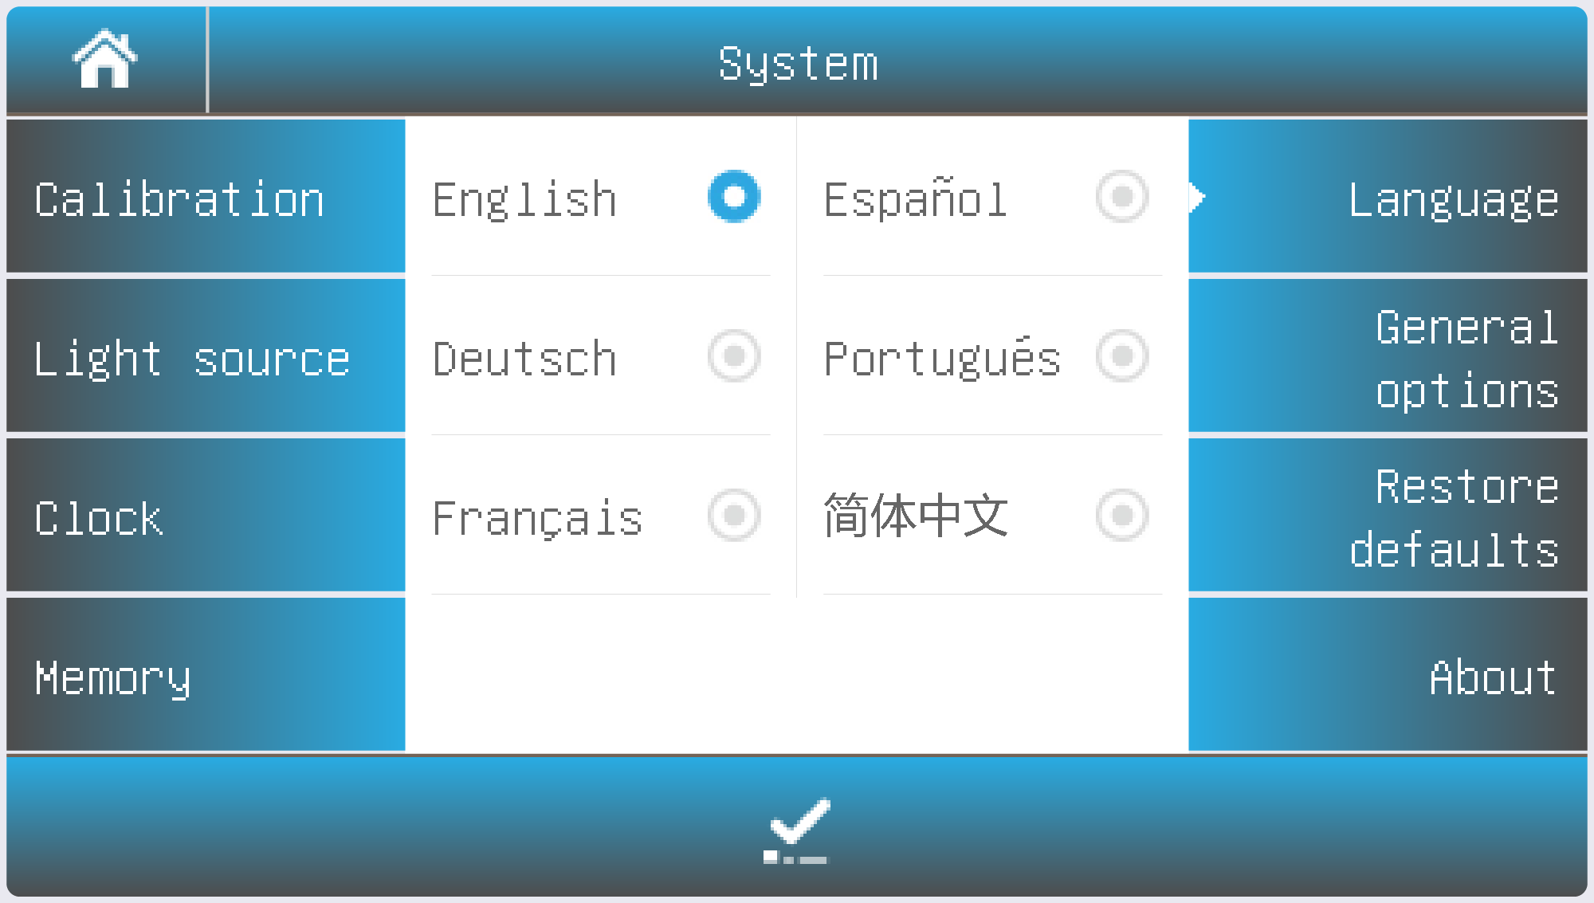
General Options
Select Tab General Options in the System interface.
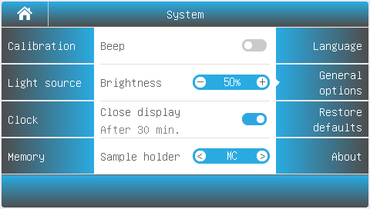
Beep: | Press the icon to turn on/off the beep.
Brightness: | Press the icon to decrease/increase the brightness of the LCD display.
Close display: | Press the icon to turn the display on/off. When turned on, the display will close automatically if there is no operation for 30 minutes.
Select sample holder | If your instrument is equipped with an automatic sample cell holder, you must configure the holder type before first use.  Press  to select the installed holder model: Auto Five-Cell Holder (AC-5) or Auto Eight-Cell Holder (AC-8).
Restore Defaults
Restore the parameters to factory settings.
Select the Tab Restore defaults in the System interface. Select an item, press the icon to restore.
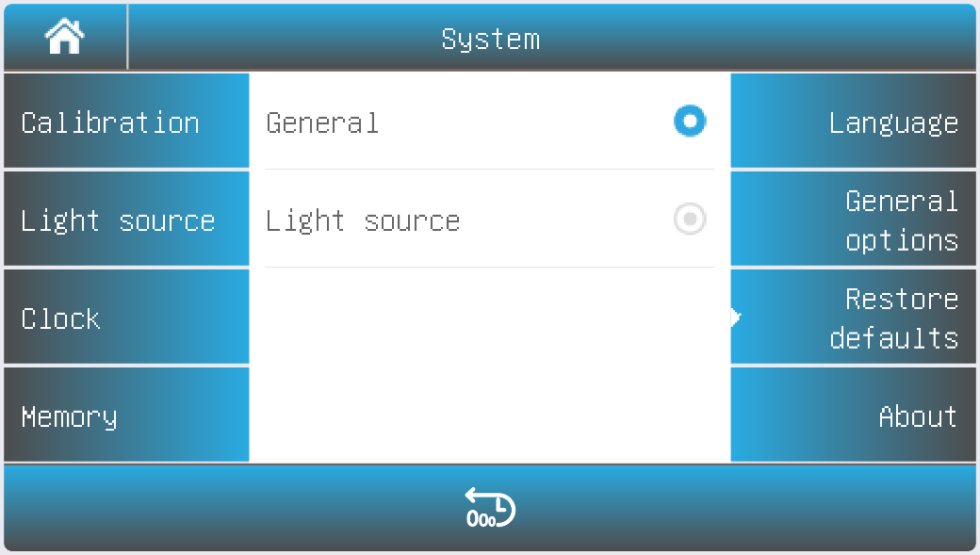
Performance Verification
Select the icon in the main interface. This will display options to verify the performance of the instrument.

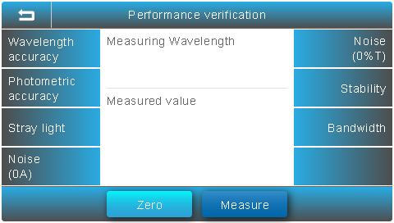
Important information Before verifying instrument performance, allow the instrument to preheat for 30 minutes. After preheating, re-measure the dark current to ensure accurate performance verification.

Verifying Wavelength Accuracy and Wavelength Repeatability
Select the Tab Wavelength Accuracy in the Performance verification interface.
Standard Sample: | Holmium oxide solution or equivalent filter
Measurement: | Prepare for Measurement  Remove any sample from the measurement channel. Close the sample chamber cover.  Press the wavelength value field, enter the desired measurement wavelength, and press the Zero button.  Measure the Standard Sample  Place the standard sample in the measurement channel and press the Measure button.  Repeat Measurements  Repeat Step 2 three times.  - The difference between the average of the three readings and the standard value represents the single-point wavelength tolerance.  - The difference between the maximum and minimum values among the three readings represents the single-point wavelength repeatability.  Verify Across Wavelengths  Repeat Steps 1–3 for each selected wavelength point.  - The maximum value among all single-point wavelength tolerances represents the instrument’s wavelength accuracy.  - The maximum value among all single-point wavelength repeatabilities represents the instrument’s wavelength repeatability.
Verifying Photometric Accuracy and Photometric Repeatability
Select Tab Photometric accuracy in the Performance verification interface.
Standard Sample: | NIST 930D or equivalent filter
Measurement: | Prepare for Measurement  Remove any sample from the measurement channel and close the sample chamber cover.  Press the wavelength value field, enter the desired measurement wavelength, and press the Zero button.  Measure the Standard Sample  Place the standard sample in the measurement channel and press the Measure button.  Repeat Measurements  Repeat Step 2 three times.  - The difference between the average of the three measurements and the standard value represents the single-point photometric tolerance.  - The difference between the maximum and minimum values among the three measurements represents the single-point photometric repeatability.  Verify Across Wavelengths  Repeat Steps 1–3 for each selected wavelength point.  - The maximum value among all single-point photometric tolerances represents the instrument’s photometric accuracy.  - The maximum value among all single-point photometric repeatabilities represents the instrument’s photometric repeatability.
Verifying Stray Light
Select Tab Stray light in the Performance verification interface.
Standard Sample: | 10g/L NaI solution or equivalent filter (220nm, UV/VISIBLE models only), 50g/L NaNo2 solution or equivalent filter (340 or 360nm)
Measurement: | Remove any sample from the measurement channel and close the sample chamber cover.  Press the wavelength value field, enter the desired measurement wavelength, and press the Zero button.  Measure the Standard Sample  Place the standard sample in the measurement channel and press the Measure button.
Verifying Noise
Select Tab Noise(0A) in the Performance verification interface.
Standard Sample: | None
Measurement: | Remove any sample from the measurement channel and close the sample chamber cover.  Press the wavelength value field, enter the desired measurement wavelength, and press the Zero button.  Measure the Standard Sample  Place the standard sample in the measurement channel and press the Measure button.
Verifying Dark Noise
Select Tab Noise(0%T) in the Performance verification interface.
Standard Sample: | Block
Measurement: | Remove any sample from the measurement channel and close the sample chamber cover.  Press the wavelength value field, enter the desired measurement wavelength, and press the Zero button.  Measure Dark Noise  Place the light-blocking device (Block) in the measurement channel and press the Measure button.  The displayed result represents the dark noise at the selected wavelength.
Verifying Stability
Select Tab Stability in the Performance verification interface.
Standard Sample: | None
Measurement: | Remove any sample from the measurement channel and close the sample chamber cover.  Press the wavelength value field, enter the wavelength 500, press the Zero button. Press the button Measure, the result is the noise of 500nm.
Verifying Bandwidth
Select Tab Bandwidth in the Performance verification interface.
Standard Sample: | Low pressure quartz mercury lamp
Measurement: | Open the lamp cover, put the low-pressure quartz mercury lamp into the lamp seat, and turn it on.  Remove any sample from the measurement channel, close the sample chamber cover, press the wavelength value, type in the wavelength 546.1;  Press the button Measure, the result is the bandwidth.

Measurement
Important Guidelines
Reagents and dilution buffers may cause burns or other health hazards. Samples such as nucleic acids, proteins, and bacterial cultures can be infectious and may cause serious damage to health. During sample preparation, measurement, maintenance, and cleaning, always follow local laboratory safety regulations. Wear appropriate personal protective equipment, including lab coats, gloves, and eye protection, and use disinfectants as required. Dispose of measurement solutions, cleaning agents, and disinfectants in accordance with local laboratory regulations.
Cuvette Inspection
Ensure that all cuvettes are clean, transparent, and free of sample residue.
Only quartz cuvettes are permitted for measurements in the UV wavelength range.

Photometry
Photometry mode is used to measure the absorbance or transmissivity of the sample.
Within the Main interface, press the icon to start a Photometry application.
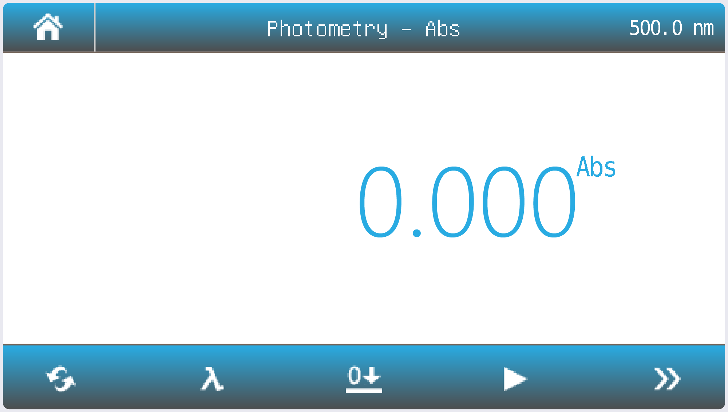
Mode Switch measurement mode to %T, Abs or Energy.
Wavelength Set measurement wavelength.
Zero Do 0Abs/100%T.
Read Measure sample and record the result.
List View the result(s) list.
Increase/Decrease the gain of signal. Only for Energy mode.
Press the icon to switch to the measurement mode.
Abs | Measure absorbance value of the sample(s).
%T | Measure transmittance value of the sample(s).
E | Measure energy value of the sample(s).
Press the icon to set wavelength, key in the measurement wavelength.
Put the reference in the measurement channel, press the icon to zero.
Put the sample in the measurement channel, press the icon to measure a sample and record the result.
Press the icon to browse the result(s).
Quantitation
Quantitation mode is used to measure the concentration of the sample(s).
Within the Main interface, press the icon to start a Quantitation application.
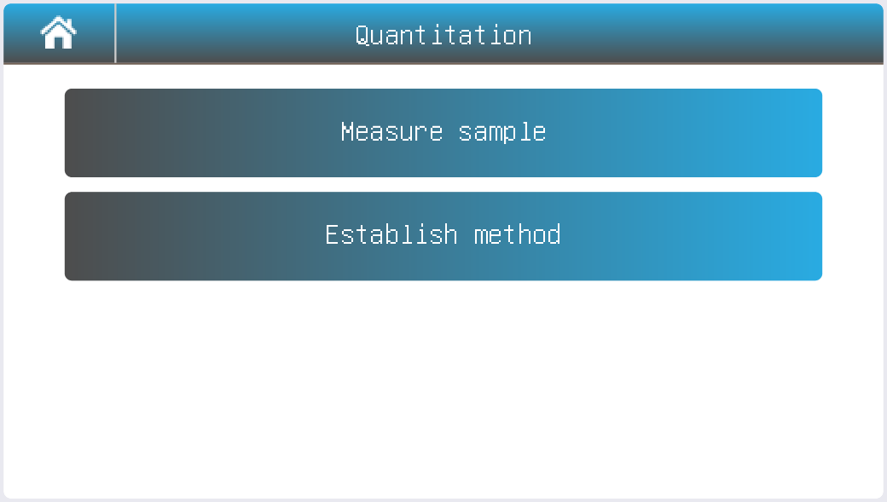
Establish Method
Within the Quantitation interface, press the button Establish method.
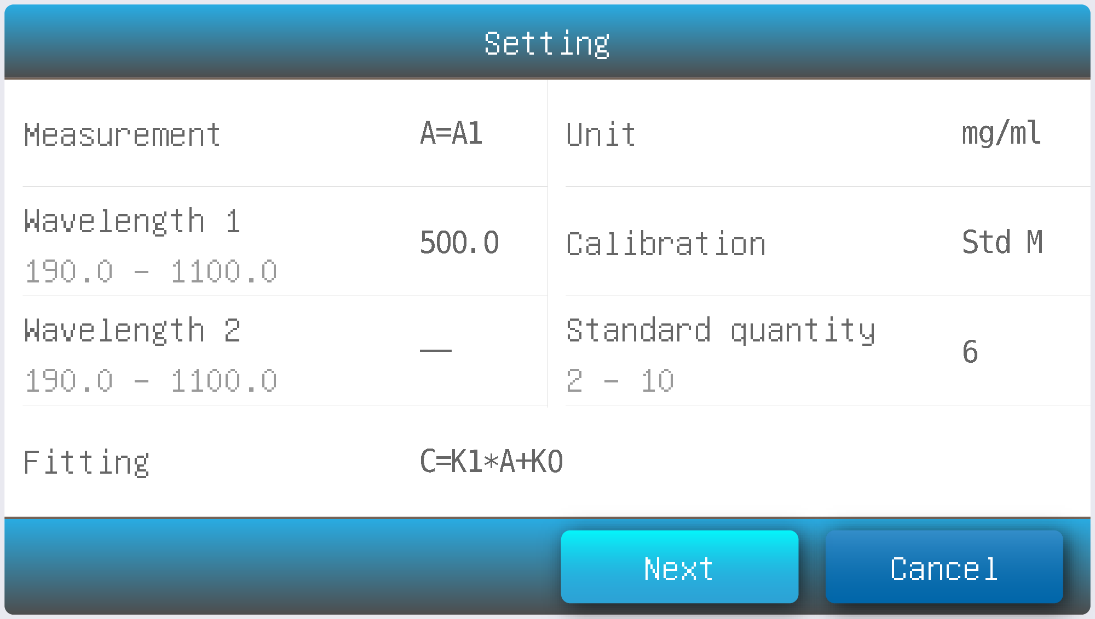
Measurement | A=A1: Absorbance is equal to the measured absorbance value of the measured wavelength 1  A=A1-m*A2: Absorbance is equal to the difference between the absorbance value of the measured absorbance at the wavelength 1 and the wavelength 2, m is the Coefficient  A=A1/A2: Absorbance is equal to the ratio of the measured absorbance value of the measured wavelength 1 and 2
Wavelength 1 | Measurement wavelength 1
Wavelength 2 | Measurement wavelength 2
Fitting | LIN-0: Linear to zero  LIN: Linear.  QUA: Quadratic.
Unit | - (No Unit), %, ppm, ppb, g/L, mg/L, μg/L, ng/L, g/dL, mg/dL, μg/dL, mg/mL, μg/mL, ng/mL, μg/μL, ng/μL, mol/L, mmol/L, IU, Custom(User input, Up to 8 characters).
Calibration | Coe K: Input equation coefficient.  Std M: Measure standard sample(s)  Std I: Input standard sample(s)
Standard quantity | Standard sample number (Up to 10)
Press the item to set measurement parameters.
After all the parameters are set up, press the button Next to start establishing the standard curve. If the item Calibration is set to the parameter Coe K, Std M or Std I, please refer to 2.3.1, 2.3.2 or 2.3.3.
Input equation coefficient to establish standard curve.
Input equation coefficient K0 ~ K3. Press button Next.
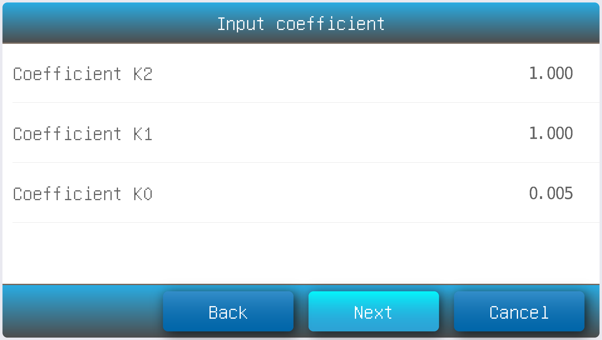
Measure standard sample to establish standard curve
Put the reference in the measurement channel, press the button Zero to do zero.
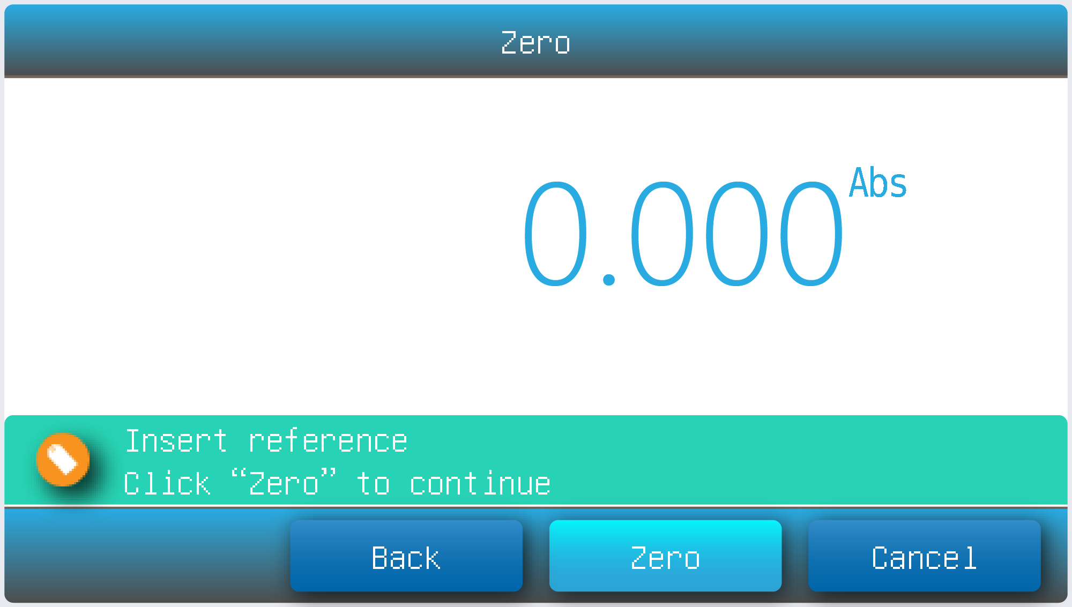
Put the 1# standard sample in the measurement channel, press the button Read to measure.
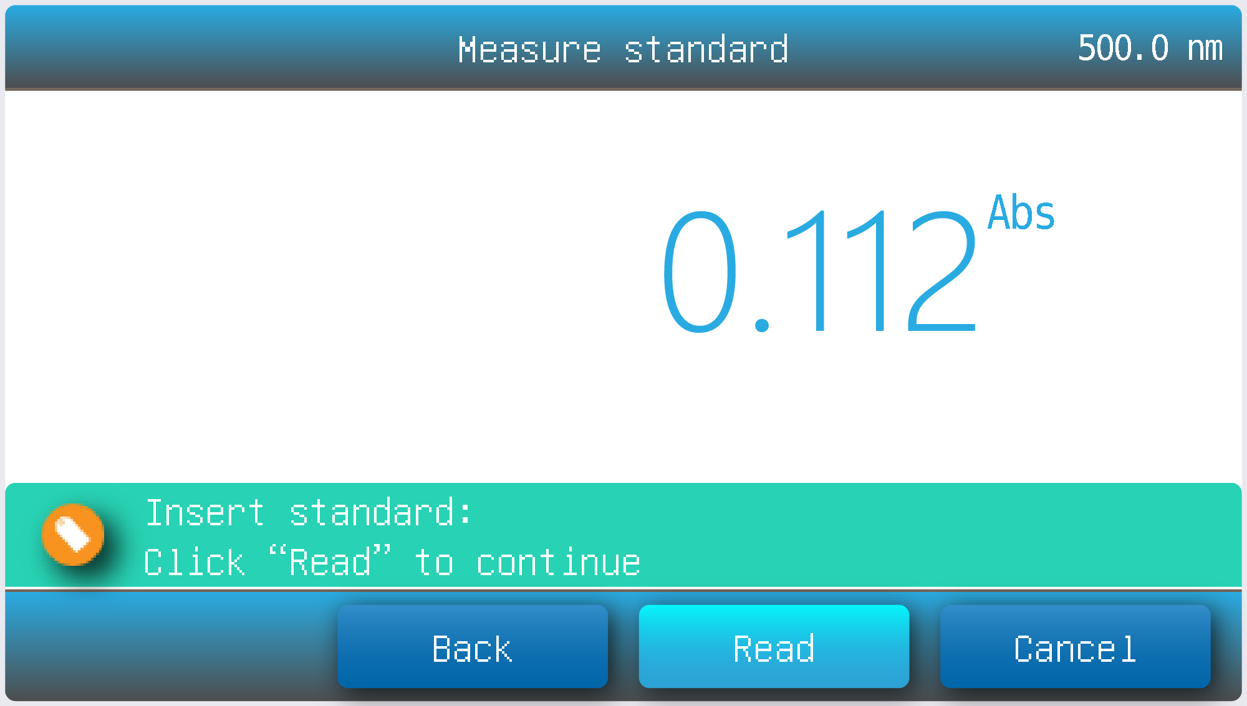
Repeat step 3.3 to measure other of the standard samples.
Press the item to input concentration of standard samples, press the button Next.
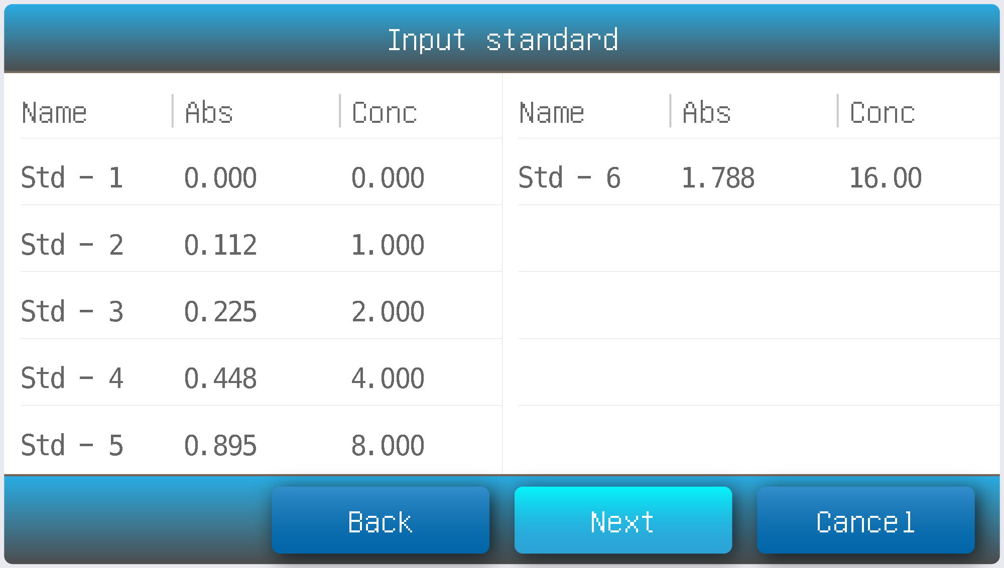
Establishing the Standard Curve
Place the standard sample in the measurement channel to establish the standard curve.
Press the Abs and Conc items to enter the absorbance and concentration of each standard sample, then press the Next button.
After completing the standard curve setup, press Save to save the method.
Press Measure to apply the new method and enter the measurement interface.
Press Finish to exit the setup.
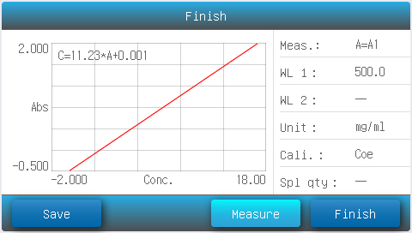
Measure Sample
Quantitation interface, press the button Measure sample.
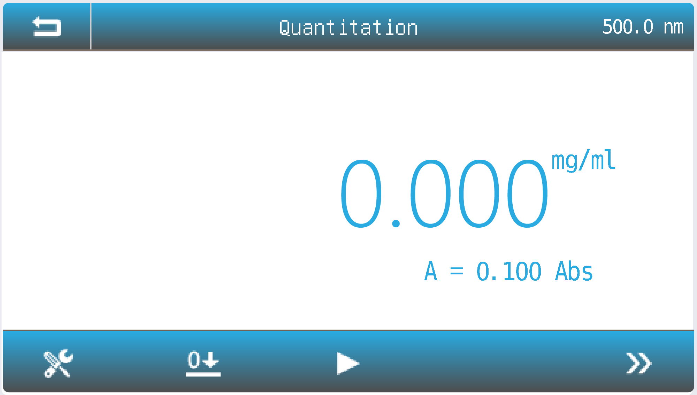
Method Select Measurement Method.
Zero 0Abs/100%T.
Read Measure the sample and record the result.
List View the result(s) list.
Press the icon to select method.
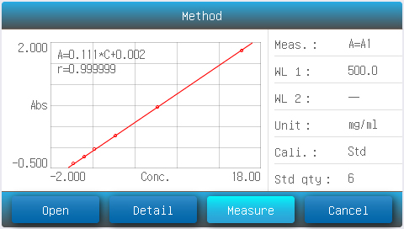
Press the Open button to load a measurement method stored in the internal memory or USB drive.
Press Measure to apply the selected method and return to the measurement interface. Put the reference in the measurement channel, press the icon to do zero.
Put the sample in the measurement channel, press the icon to measure a sample and record the result.
Press the icon to browse the result(s).
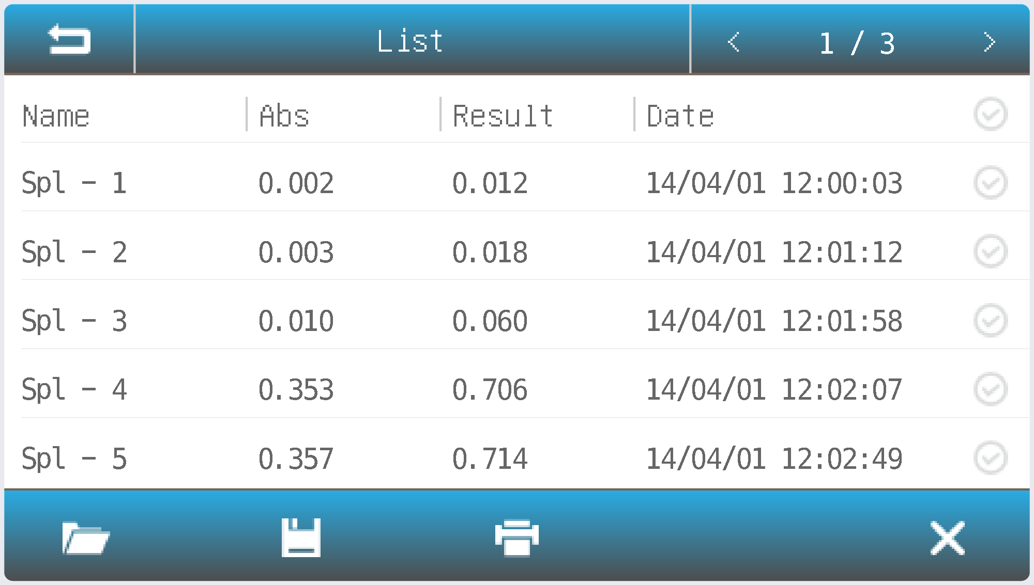
Spectrum
Spectrum mode is used to scan the absorbance or transmissivity of the sample in a wavelength range.
Within the Main interface, press the icon to start a Spectrum application.
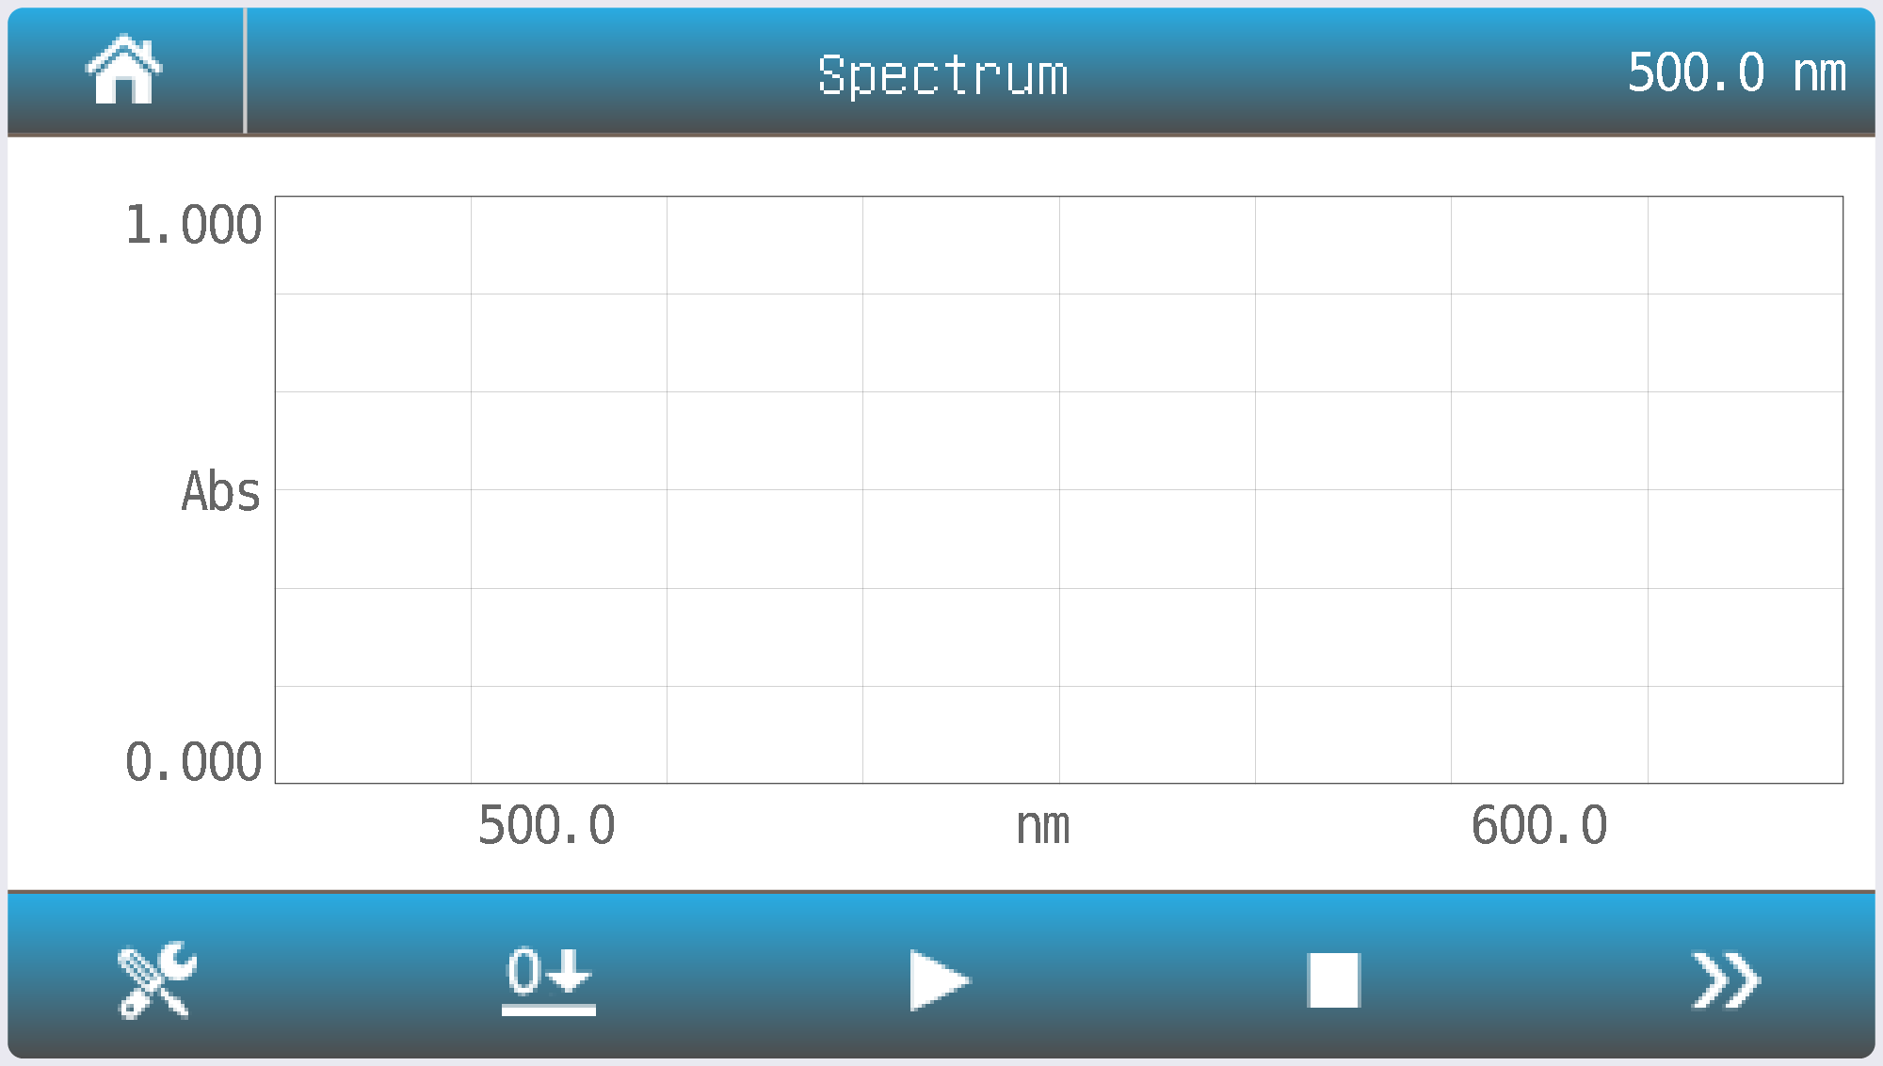
Method Set the measurement parameters.
Zero Scan baseline.
Read Scan the sample and draw curve.
Stop scanning.
List View the result(s) list.
Press the icon to setup the measurement parameters.
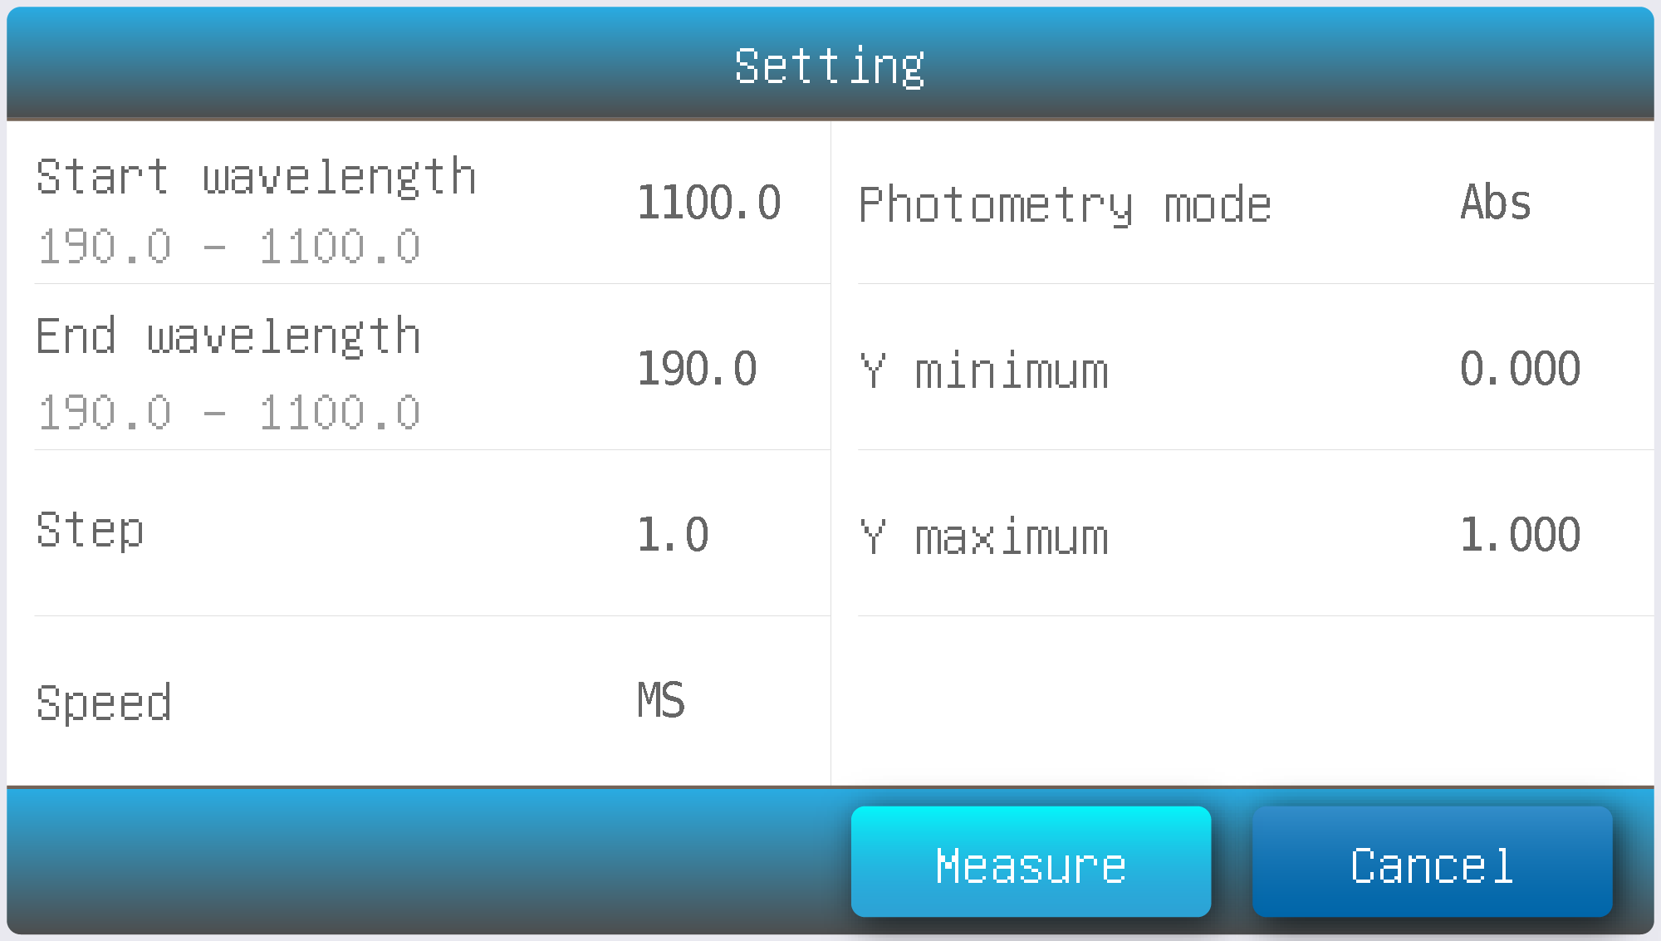
Start wavelength | Scan start wavelength
End wavelength | Scan end wavelength
Step | Scan interval: 0.1,0.2, 0.5, 1.0,2.0, 5.0,10.0 nm
Speed | HS: High speed  MS: Medium speed  LS: Low speed
Photometry mode | Abs: absorbance  %T: transmissivity
Y minimum | Minimum ordinate
Y maximum | Maximum ordinate
Press the item to select or key in the parameters, press the Measure button to accept the new parameters and back to measurement interface.
Put the reference in the measurement channel, press the icon to scan baseline.
Put the sample in the measurement channel, press the icon to scan a sample and record the result.
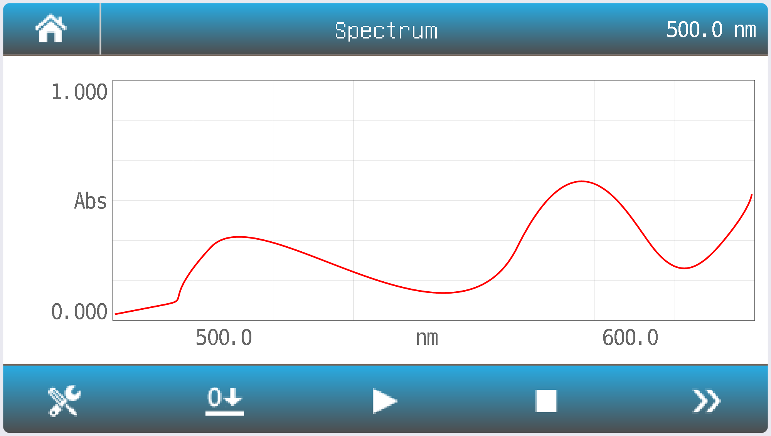
Press the icon to browse the curve and result(s).
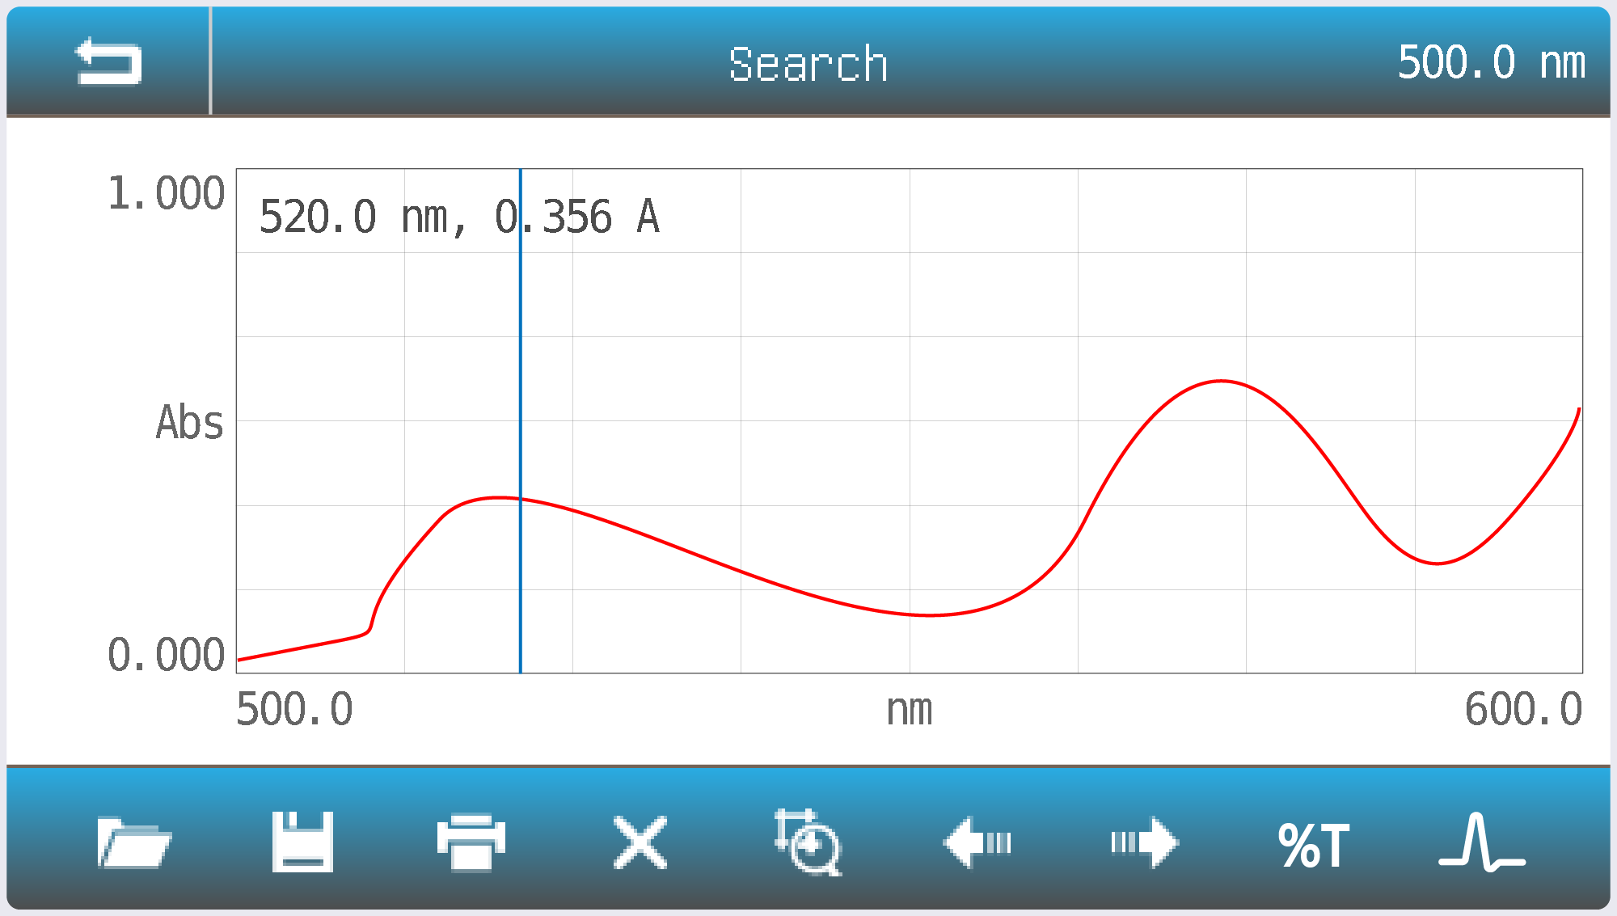
Scale Set the Coordinate value.
Left Moves the cursor to the left point (peak) to point(peak).
Right Moves the cursor to the left point (peak) to point(peak).
Mode %T Change the mode to %T.
Mode Abs Change the mode to Abs.
Point/Peak Change the search mode point/peak.
Troubleshooting
Review the information in the table below to solve operating problems.
Problem | Cause | Solution
Power on, no response | Power cord connection is not reliable | Improve connectivity
Power on, no response | Fuse burning | Replace fuse
Measurement uncertainty | Sample is not Stable | Improve the sample
Measurement uncertainty | Glass cuvettes used in UV Range | Use quartz cuvettes
Measurement uncertainty | The concentration of sample is too high | Diluted sample
Measurement uncertainty | Power Supply Voltage Low or not Stable | Improve the Power Supply
Measurement uncertainty | Lamp damage or lamp life maturity | Replace lamp
Dark Current Error when self-check | The lid of the compartment is open during self-check | Close the lid, restart
System Calibrate Failed | Something blocks the Light path | Remove it, calibrate again
Measurements inaccurate | Cuvettes were contaminated | Clean cuvettes
Measurements inaccurate | Samples were contaminated | Improve samples
Measurements inaccurate | Worse matching of the cuvettes | Improve the matching of the cuvettes
Measurements inaccurate | Dark current error | Resample dark current

Repair and Maintenance
Check the Sample Compartment
After each measurement, promptly remove the cuvettes containing sample solutions from the compartment. If left inside, evaporation may cause condensation and lead to mold formation on the optical mirrors.
Pay special attention when using corrosive or highly volatile samples. Immediately wipe off any spilled or residual liquid inside the compartment using a soft, lint-free cloth.
Clean the Instrument Surface
The instrument cover is coated with protective paint. Wipe any spills or drips from the surface immediately using a damp cloth.
Do not use organic solvents or abrasive cleaners, as these may damage the finish. Clean any dirt or residue from the cover regularly to maintain the instrument’s appearance and durability.
Clean the Cuvettes
After each measurement or whenever the sample solution is changed, carefully clean the cuvettes. Residual liquid or contamination on the cuvette surfaces can cause measurement errors. Ensure the cuvettes are completely dry before reuse or storage.

Spare Parts Replacement
Replace the fuse
Danger! Be sure to switch off the power and unplug the socket before replacement!
Tools preparation
Prepare a 3×75 Flat Blade screwdriver.
Switch Off the power supply
Switch off the power supply and unplug the socket.
Take out the Fuse Seat
Push the fuse case by using the screwdriver, and turn it counterclockwise, the fuse seat will pop out when released.
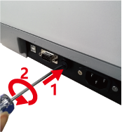
Replace a new fuse
Pick out the spare fuse (3.15A/250V) and replace it.
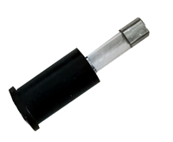
Reset the fuse seat
Replace the fuse seat in the power socket. Push the fuse case by using the screwdriver, and turn it clockwise, the fuse seat will be locked when released.
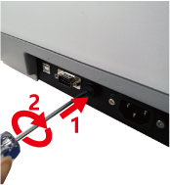
Switch on the power
Plug the socket and switch on the power.
Replace lamps
Hot! Wait 20 minutes before opening the lamp chamber after power off to avoid
scald!
Tools preparation
Prepare a 6×150mm Flat Blade screwdriver and a pair of gloves.
Power Off
Switch off the power supply and unplug the socket.
Open the cover
Loosen the two indicated screws and remove the lamp cover.
Replace the D2 lamp
If your spectrophotometer is visible model, please skip to step 5.
Unplug the connector (No. 2). Unscrew the 2 screws on the D2 Flange (No.1) and remove the D2 lamp. Draw on the cotton glove and replace the new lamp. Fix the 2 screws and plug the connector again.
Replace W lamp
The Tungsten lamp is equipped with a blue-grey silicon coating by manufacturer. This coating is only a transport safety device. It can be removed with the first exchange of lamp.
Pull out the defected W lamp and draw on the cotton glove. Insert the new W lamp as deep as possible on the lamp seat. Be sure to keep the filament in the same direction as the old one face.
Adjust the position of the W lamp
Switch on the power (the Switch Mirror should be placed to the position as indicates). Observe the entrance facular, and it should in the center of the entrance hole. If the facular deviates to Left or Right, then loosen the two screws and move the lamp seat to Left or Right until it focus on the center of the slot. Then fix the screws.
Finish
Reset the cover of the light chamber and fix the screws. Reset the cover of the lamp room and fix the screws.

Warranty
We warrant that this product is free from defects in materials and workmanship for a period of one (1) year from the date of delivery. If a defect is found during this period, we will, at our discretion and expense, repair the product, replace it, or refund the original purchase price, provided the product is returned within the warranty period.
This warranty does not apply to products that have been damaged as a result of accident, abuse, misuse, improper application, or normal wear and tear. Failure to perform the required maintenance or inspection services in accordance with the operating manual or applicable local regulations will render this warranty void, except where the defect is proven to be unrelated to such non-performance.
Products returned under warranty must be properly insured by the customer against loss or damage during shipment. This warranty is limited to the remedies specified above. IT IS EXPRESSLY AGREED THAT THIS WARRANTY IS IN LIEU OF ALL OTHER WARRANTIES, WHETHER EXPRESS OR IMPLIED, INCLUDING ANY WARRANTY OF MERCHANTABILITY OR FITNESS FOR A PARTICULAR PURPOSE.


Compliance with Local Laws
The customer is responsible for applying for and obtaining the necessary regulatory approvals or other authorizations necessary to run or use the Product in its local environment. WE will not be held liable for any related omission or for not obtaining the required approval or authorization, unless any refusal is due to a defect of the product.
Equipment Disposal

This equipment is marked with the crossed-out wheeled bin symbol, indicating that it must not be disposed of with unsorted municipal waste.
At the end of its service life, it is your responsibility to ensure proper disposal by delivering the equipment to an authorized collection or recycling facility.
If the equipment has been exposed to biological, chemical, or radiological materials, it must be decontaminated prior to disposal to protect the health and safety of personnel handling recycling and waste processing.
For information on authorized collection points or recycling options, please contact your local distributor or dealer from whom the equipment was purchased.
By disposing of this equipment responsibly, you are helping to conserve natural resources and protect human health and the environment.
Thank you for your cooperation.


609.642.6840 | info@mpdscientific.com
www.mpdscientific.com
Copyright ©2025 MPD Scientific Inc

